En-sdwan-30-coreconcepts
SD-WAN Evolution and Core Concepts
Student Guide
Volume number
Version Number
Part Number

Copyright Notices
© 2025 Cisco Systems, Inc.
© 2025 Cisco Systems, Inc.

Americas Headquarters  Cisco Systems, Inc.  San Jose, CA | Asia Pacific Headquarters  Cisco Systems (USA) Pte. Ltd.  Singapore | Europe Headquarters  Cisco Systems International BV Amsterdam,  The Netherlands
Cisco has more than 200 offices worldwide. Addresses, phone numbers, and fax numbers are listed on the Cisco website at http://www.cisco.com/go/offices.
Cisco and the Cisco logo are trademarks or registered trademarks of Cisco and/or its affiliates in the U.S. and other countries. To view a list of Cisco trademarks, go to this URL:http://www.cisco.com/c/en/us/about/legal/trademarks.html. Third-party trademarks that are mentioned are the property of their respective owners. The use of the word partner does not imply a partnership relationship between Cisco and any other company. (1110R)
DISCLAIMER WARRANTY: THIS CONTENT IS BEING PROVIDED “AS IS” AND AS SUCH MAY INCLUDE TYPOGRAPHICAL, GRAPHICS, OR FORMATTING ERRORS. CISCO MAKES AND YOU RECEIVE NO WARRANTIES IN CONNECTION WITH THE CONTENT PROVIDED HEREUNDER, EXPRESS, IMPLIED, STATUTORY OR IN ANY OTHER PROVISION OF THIS CONTENT OR COMMUNICATION BETWEEN CISCO AND YOU. CISCO SPECIFICALLY DISCLAIMS ALL IMPLIED WARRANTIES, INCLUDING WARRANTIES OF MERCHANTABILITY, NON-INFRINGEMENT AND FITNESS FOR A PARTICULAR PURPOSE, OR ARISING FROM A COURSE OF DEALING, USAGE OR TRADE PRACTICE. This learning product may contain early release content, and while Cisco believes it to be accurate, it falls subject to the disclaimer above.

Course Welcome
Thank you for choosing Cisco as your technical learning provider. We recognize that you have many options to choose from when working toward achieving your technical and professional goals. Our objective is to help you meet those goals by providing high-quality, collaborative learning experiences.
Before you begin, take a moment to review the primary components in this course, how to access online support, and opportunities to provide feedback on the course.
Course outline: If you are attending a live, instructor-led training session, your instructor may customize the course to meet the specific needs of the class. However, you will find a basic outline of the material in the Course Introduction section.
Course content: You will find detailed information and instructions along with supporting illustrations, self-check challenges to give you exam practice, and lab activities to give you a real-world experience.
Bias-Free language: Cisco is updating content to be free of offensive or suggestive language. We are changing terms such as blacklist/whitelist and master/slave to more appropriate alternatives. While we update our portfolio of products and content, users may see differences between some content and a product’s user interface or command syntax. Please use your product’s current terminology as found in its documentation.
Online support: Join the Cisco Learning Network community to participate in study group discussions and get answers to questions as you prepare for your exam.
Your feedback: We encourage you to submit feedback so that we can continue to improve course quality and offer the best learning products possible. Your input is valuable to us, and we want to know how the course has helped with your job and exam performance. There are two ways to submit feedback:
- Course evaluation survey: If you attend a live, instructor-led training session, then your instructor will provide a survey on the last day of class. After completing the survey, you'll receive a course completion certificate. Once you've had a chance to practice what you've learned, you’ll receive a follow-up survey approximately two months after completing the course.
- Digital kit feedback: Use the Feedback button in the digital version of the course materials to submit your comments.
We make regular updates to our content in response to your feedback, so please share it with us.
Special thanks to our Cisco Authorized Learning Partners in making these materials available.
Thank you again for choosing Cisco.

Table of Contents

Section 1: SD-WAN Evolution and Core Concepts 1
Traditional WAN Limitations and Modern Demands 3
Business Drivers and SD-WAN Value 11
Underlay vs. Overlay Architecture 19
Intelligent Control Principles 32
Policy and Security Principles 38
Agile Operations and Review 44
Cisco Catalyst SD-WAN: Unlocking Modern WAN Agility – A Strategic Imperative 49
Summary 50
Summary Challenge 52
Answer Key 53

Section 1: SD-WAN Evolution and Core Concepts
Introduction
Imagine you’re a Senior Network Architect responsible for the network that connects your company’s offices, remote workers, and cloud applications across the country. You’ve managed everything from adding new sites to handling frustrated users when applications slow down. Each week brings new demands: supporting cloud services, speeding up deployments, and keeping costs in check — often with the same legacy WAN setup you’ve relied on for years.
 | Your current WAN infrastructure has served you well, but how can you evolve your network to meet today’s cloud-driven, distributed, and agile business needs without sacrificing security or control?

You know that your business is changing fast. Cloud and SaaS adoption are rising, users expect seamless connectivity everywhere, and traditional WAN designs are starting to hold you back. High costs, complex manual configurations, and poor cloud performance are becoming daily challenges for your team.
In this course, you will learn:
- The foundational concepts and principles behind the Cisco Catalyst SD-WAN solution and how they solve real-world business and technical pain points.
- How Cisco Catalyst SD-WAN redefines connectivity with a software-defined, policy-driven approach.
- The key limitations of traditional WANs in the face of cloud and remote work trends.

Your journey starts by identifying the gaps in legacy WANs and discovering how a modern SD-WAN can position your organization for the future.
Now, it's time to get started!
Case Study: Modernizing Your Enterprise WAN
Your company is a rapidly expanding enterprise with numerous branch offices, a central data center, and an increasing reliance on cloud-based applications. For years, your company relied on a traditional WAN architecture built on expensive MPLS circuits and a centralized security model that backhauls all branch traffic through the data center.
The following figure represents a legacy WAN design struggling to keep up with cloud-first business demands.
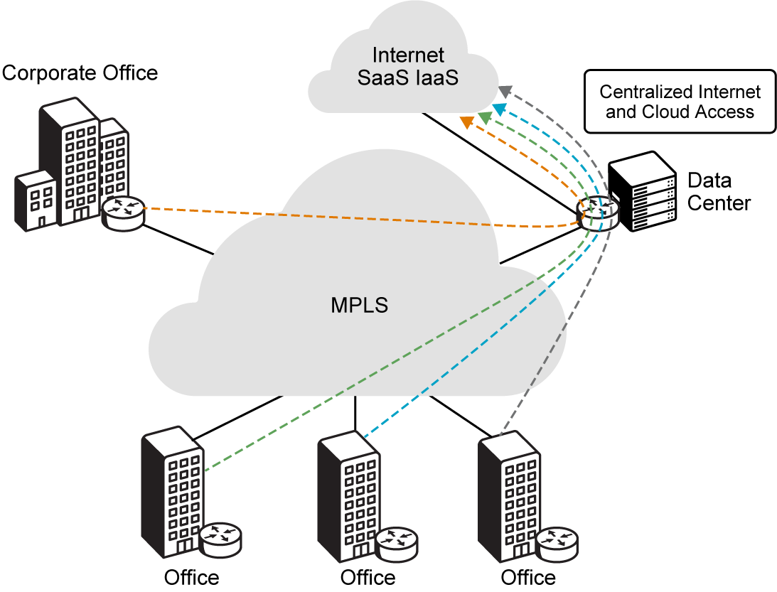
 | As a Senior Network Architect, you've been hearing growing complaints from employees about slow access to cloud applications, especially in remote branches. Furthermore, a lengthy process can slow down the business if it takes months to deploy network services for new branch offices or integrate new business applications. The current network is complex to manage, prone to configuration errors, and struggles to adapt to rapid changes in business demands.

You recognize that the legacy WAN is hindering your company's digital transformation goals and impacting overall operational efficiency. You see an urgent need to modernize the network infrastructure to improve user experience, reduce costs, and accelerate business agility.
As you progress through this course, consider how the concepts of Cisco Catalyst SD-WAN can address these challenges. You will explore:
- How Cisco Catalyst SD-WAN can alleviate slow cloud application access.
- How it can drastically reduce the time needed to deploy new branch offices.
- How it simplifies network management and enhances security across a distributed environment.

Addressing these considerations builds the foundation for Cisco Catalyst SD-WAN to support your company's needs today and provide a robust platform for future growth.

Traditional WAN Limitations and Modern Demands
The WAN serves as the critical backbone connecting an enterprise's distributed locations, data centers, and, increasingly, cloud-based applications and services. For decades, traditional WAN architectures, like MPLS and point-to-point circuits, served their purpose. However, the emergence of new technologies and shifts in business operations have exposed significant limitations in these legacy designs.
 | This topic explores the shortcomings of traditional WANs. It shows how modern demands, driven by cloud computing, Software-as-a-Service (SaaS) applications, and remote work, make these architectures inefficient, costly, and complex.

The Challenges of Traditional WAN Architectures
Traditional WAN designs were robust for their time. However, they are ill-suited for the dynamic, cloud-centric, and distributed nature of modern enterprises. The core challenges can be categorized as follows:
High Cost
High Cost: Legacy networks often use expensive dedicated hardware and costly transport connections, such as MPLS circuits. While reliable, these circuits come with a premium price. This can be prohibitive, especially for companies like yours with many branch offices.
These circuits may also lack the bandwidth needed for today's high-demand applications, forcing costly upgrades. Operational expenses for managing these complex systems significantly increase the total cost of ownership.
The following figure illustrates how traditional WAN designs drive up connectivity costs.
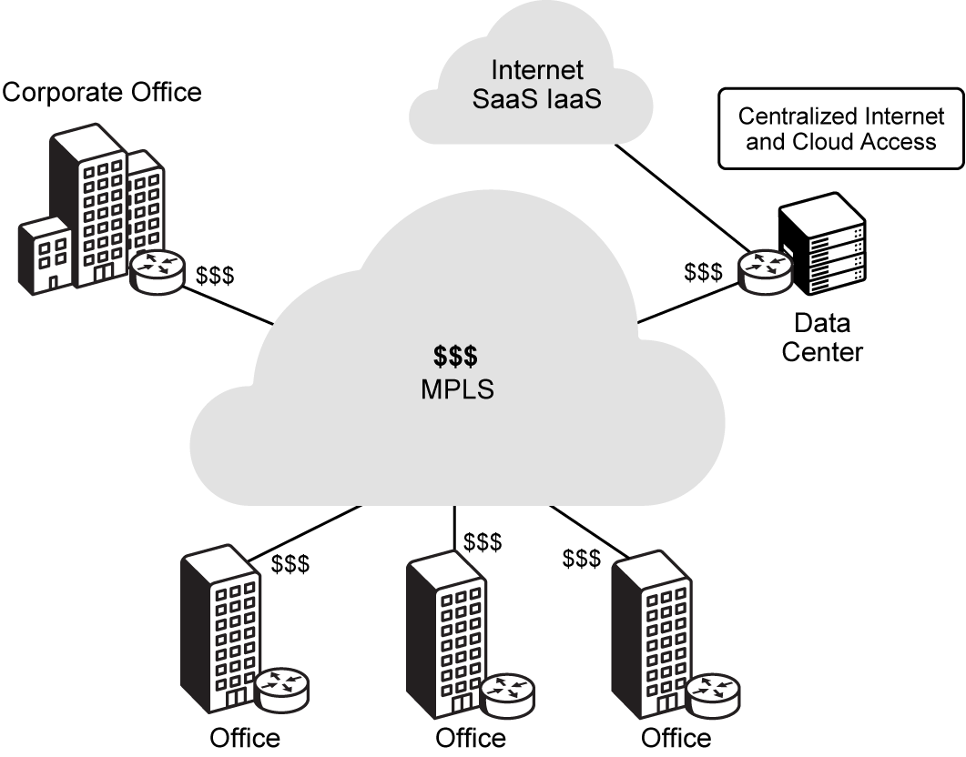
Real-World Scenario: Your CFO frequently questions the escalating monthly bills for your dedicated MPLS circuits, asking why your company can't leverage more affordable internet options like its competitors.
Why it Matters: High costs directly impact your company's bottom line and competitive edge. Reducing WAN expenses can free up capital for other strategic investments, improving overall business profitability.
Engineer Insight: Expensive dedicated circuits often come with long contracts and limited flexibility. When calculating the true cost, consider not just the circuit itself, but also the hardware, maintenance, and administrative overhead. These factors add significantly to the total cost of ownership for legacy connections.
Complexity
Complexity: Traditional WANs typically use a distributed control plane. This means that you must individually configure every network device, like routers and switches, with routing and security rules. This decentralized approach makes managing remote sites, implementing changes, and performing network maintenance a significant logistical challenge for your team.
Manual configurations are prone to human error. They also lead to configuration drift across the network, increasing troubleshooting time and reducing overall network stability. Scaling these networks often adds more complexity, rather than simplifying it.
The following figure highlights the configuration complexity of a traditional WAN.
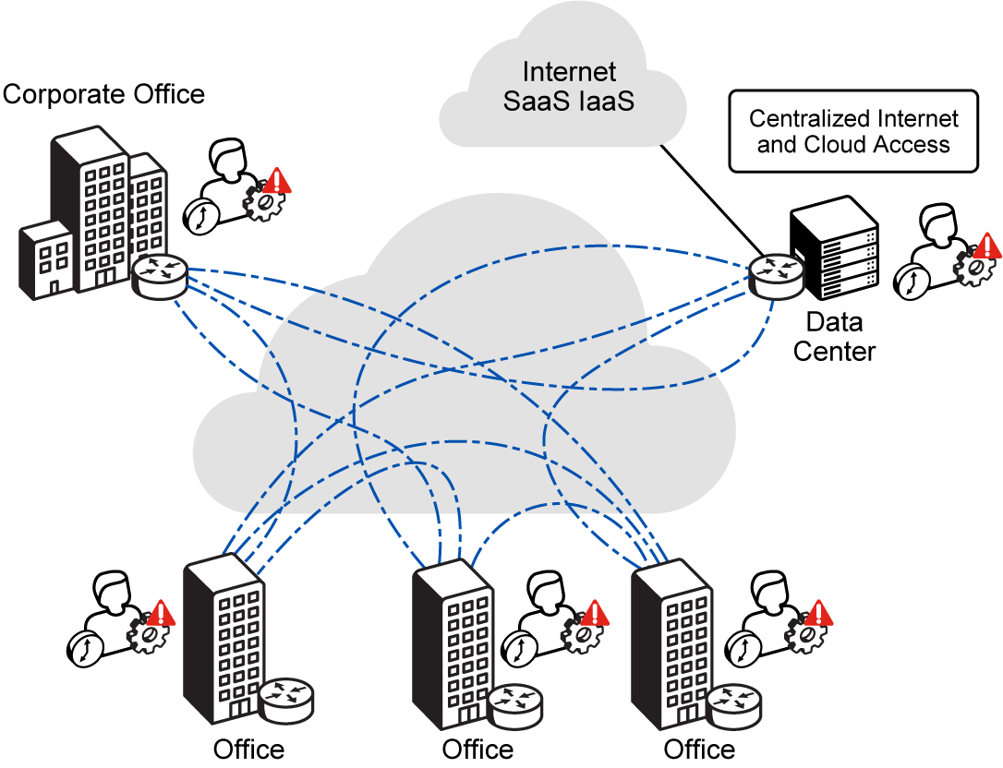
Real-World Scenario: Your company faces a critical network change. This requires manual updates across dozens of routers in different time zones. Despite meticulous planning, a minor typo leads to a multi-hour outage in a remote branch, impacting critical operations and frustrating your users.
Why it Matters: High network complexity leads to increased operational costs, higher risk of outages, and slower response times. This directly impacts your company's ability to maintain reliable services and adapt quickly.
Engineer Insight: Every manual configuration is a potential point of human error. In a distributed control plane, maintaining consistency and troubleshooting issues across many individually managed devices becomes a significant operational burden. This consumes valuable engineering time that could be spent on strategic initiatives.
Rigidity
Rigidity and Slow Provisioning: Deploying new branch locations or integrating new services into a traditional WAN is often a time-consuming process. Relying on carriers to install new circuits can take months. This dramatically delays business expansion and agility for your company.
The static nature of these connections makes it difficult to quickly adapt to changing business needs or network conditions. This hinders rapid response to market opportunities and slows down digital transformation initiatives. This lack of agility directly impacts your company's ability to compete in a fast-paced market.
The following figure represents how traditional WANs slow down new site turn-up.
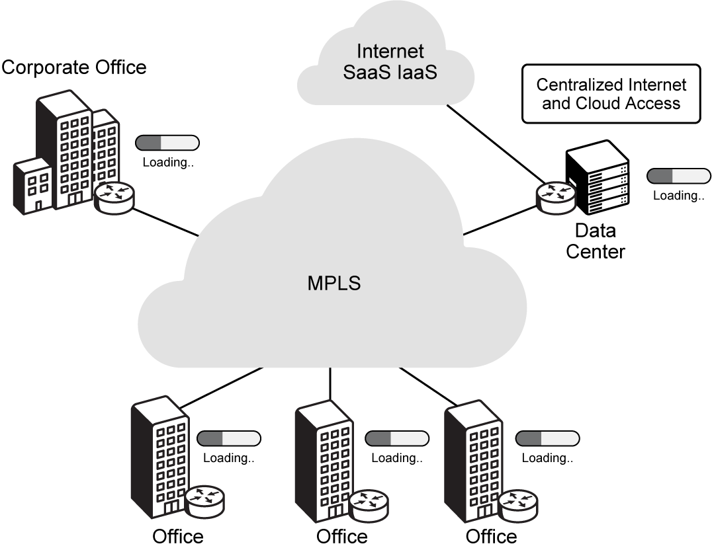
Real-World Scenario: Your company needs to open a new sales office in a rapidly growing region. However, the traditional WAN circuit installation is quoted at four months. This delay causes you to miss a critical market window and lose potential revenue, directly impacting your business's ability to capitalize on new opportunities.
Why it Matters: Slow provisioning directly impedes business growth and competitive advantage. The inability to rapidly deploy new sites or services can result in lost revenue and missed market opportunities.
Engineer Insight: Lengthy lead times for traditional circuit provisioning severely hinder business expansion and digital transformation. As an engineer, recognizing this rigidity means advocating for solutions that enable rapid deployment and agile adaptation to changing business needs, rather than being constrained by infrastructure limitations.
Backhaul
Inefficient Backhauling for Cloud Traffic: Network traffic patterns have shifted significantly with the rise of cloud and SaaS applications. In a traditional WAN, all branch traffic, including internet-bound and cloud-bound traffic, is often "backhauled" through a central data center. This is done for security inspection and policy enforcement.
This creates unnecessary latency, degrades application performance, and consumes expensive data center bandwidth. The result is a poor user experience. This model, once logical for on-premises applications, is now a significant bottleneck for cloud-destined traffic. It forces traffic to travel a longer, suboptimal path.
The following figure shows how backhauling traffic through a data center hurts cloud performance.
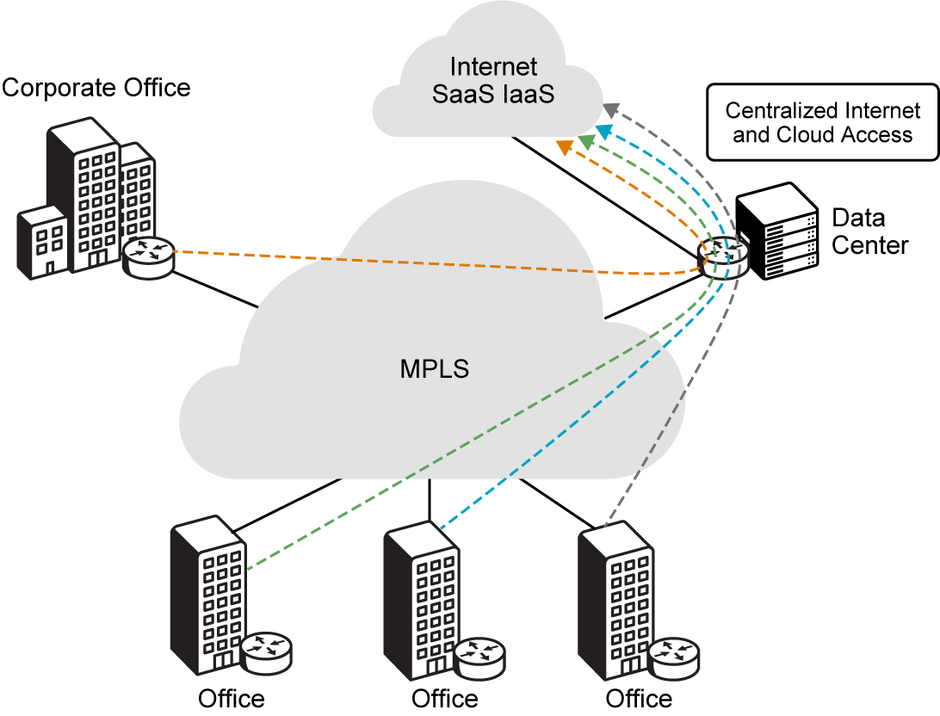
Real-World Scenario: Employees in your remote branch offices frequently complain about slow performance for core applications. This happens even though the branch has a high-speed local internet connection. The root cause is that all their cloud-bound traffic is forced to travel hundreds of miles to the central data center for security inspection before reaching the internet. This creates unnecessary delays and a poor user experience for your colleagues.
Why it Matters: Poor cloud application performance directly impacts employee productivity and satisfaction. It can also lead to increased support calls and hinder the adoption of critical cloud services across your organization.
Engineer Insight: When users report 'slow internet,' dig deeper. Is it all traffic, or specific cloud/SaaS applications? This often points directly to backhauling inefficiencies. Understanding the specific applications experiencing slowness can help you pinpoint the root cause in a backhauled environment.
App Aware
Limited Application Awareness: Legacy networks often need complex and static Quality of Service (QoS) configurations to prioritize business-critical applications. Manually updating or modifying these configurations across a large network is lengthy and prone to errors. This approach lacks the dynamic adaptability needed for modern, diverse application portfolios.
Ensuring critical application performance becomes a constant, reactive battle. The network struggles to differentiate and prioritize various application types. This can lead to a "flat" network where all traffic is treated equally, impacting critical business functions.
The following figure illustrates the lack of application awareness in traditional WAN routers.
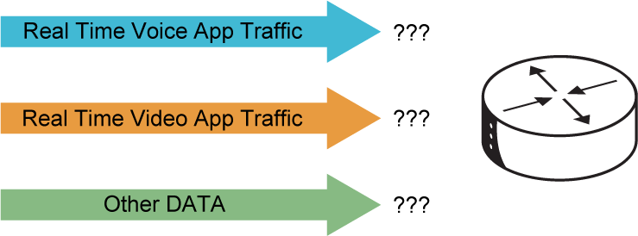
Real-World Scenario: Users at your company report that their critical CRM application is slow, but network monitoring shows plenty of bandwidth. The problem is that the network treats all traffic equally. Non-essential downloads are consuming resources needed by the business-critical application, directly impacting sales team efficiency.
Why it Matters: Inconsistent application performance directly impacts employee productivity and business operations. Critical applications, like CRM or VoIP, need guaranteed performance to ensure smooth workflows and customer interactions.
Engineer Insight: Without the ability to intelligently identify and prioritize applications, your network is essentially 'blind.' Static QoS configurations are often rigid and difficult to scale. This leads to a reactive approach where you're constantly fighting fires instead of proactively ensuring performance for key business tools.
Security
Security Gaps: Traffic is often backhauled for centralized security. However, this model becomes inefficient as more applications move to the cloud. Branches need direct and secure internet access to avoid latency.
Traditional security models struggle to extend end-to-end security to every branch and remote user. This often requires complex, localized deployments, potentially leaving distributed edges vulnerable. This creates a trade-off between performance and security: optimizing one often compromises the other.
The following figure depicts the security challenges of protecting a distributed WAN.
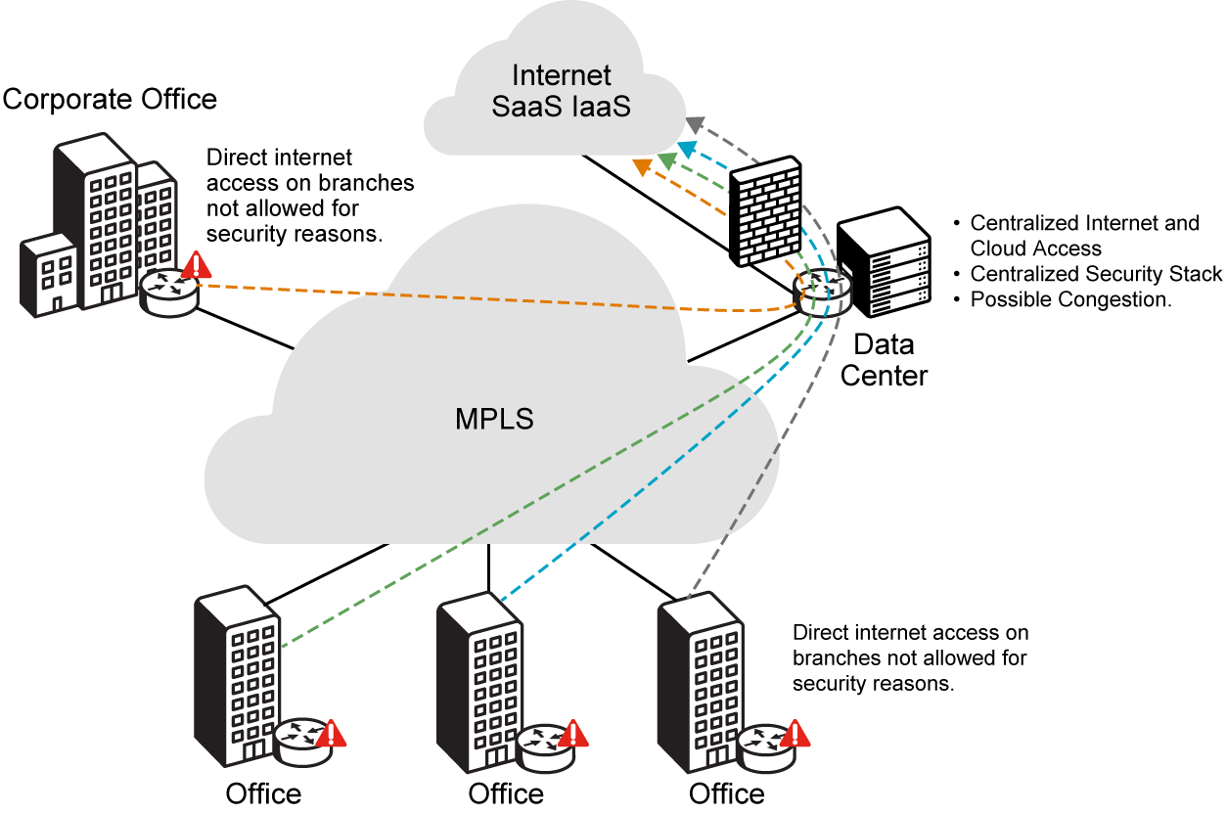
Real-World Scenario: Your security team wants to implement advanced threat detection at every branch. However, deploying and managing individual security appliances at each remote site is too complex and costly. This leaves some locations with basic protection only, creating potential vulnerabilities for your company.
Why it Matters: Security gaps expose your company to increased risk of cyberattacks, data breaches, and compliance violations. This can lead to significant financial losses, reputational damage, and legal repercussions.
Engineer Insight: As traffic shifts directly to the internet from branches, relying solely on a central data center for security creates a 'performance vs. security' dilemma. Extending consistent, granular security to every edge without compromising user experience is a major challenge for traditional models.
1. Which of the following most directly describes an operational challenge caused by the "Rigidity and Slow Provisioning" limitation in traditional WANs?
A. The requirement to manually configure every network device individually.
B. The inability to dynamically prioritize business-critical application traffic.
C. Lengthy lead times for installing new circuits and bringing new sites online.
D. The necessity to route all branch traffic through a central data center for security inspection.
2. A network engineer is troubleshooting slow performance for a new cloud-based CRM application accessed by users in a branch office. Which traditional WAN limitation is most likely contributing to this issue?
A. High cost of MPLS circuits.
B. Limited application awareness.
C. Rigidity and slow provisioning.
D. Inefficient backhauling for cloud traffic.
 | Think Like an Engineer: Prioritizing Modernization  Your CEO has tasked you with a WAN modernization initiative, but resources are limited. Of the traditional WAN limitations discussed, which two would you prioritize to deliver the most significant business impact for a cloud-first, rapidly expanding enterprise, and why?  - Consider which pain points most directly impact revenue, agility, and user experience in a cloud-first world.

 | Key Takeaway: The Strategic Imperative for Your Company  Understanding these traditional WAN limitations is crucial for you as a network professional.  The compounding effects of these challenges for your company include:  - Hindered Business Agility and Expansion: High costs, inherent complexity, and rigid provisioning directly impede your company's ability to grow and adapt.  - Compromised Performance and Security: The struggle to provide consistent security and optimal performance for cloud-based applications highlights a critical need for modernization.  - Advocacy for Transformation: Recognizing these pain points is the first step in advocating for a solution that can transform your company's operational efficiency and user experience.  Ultimately, this problem-driven understanding positions you to champion essential network modernization, transforming your WAN into a strategic asset for future business success.

Business Drivers and SD-WAN Value
You've seen the clear limitations of traditional WANs. Now, you need a network that is robust, secure, agile, and cost-efficient. It must also integrate deeply with cloud and SaaS ecosystems. This is where Cisco Catalyst SD-WAN offers a transformative solution for your company.
 | Building on our understanding of traditional WAN limitations, let's now explore the approach of Cisco Catalyst SD-WAN and how its core architectural shifts address challenges and deliver tangible business value.

The Vision of Cisco Catalyst SD-WAN
Cisco Catalyst SD-WAN fundamentally changes WAN design. It moves from hardware-centric, manual configurations to a secure, software-defined, and policy-driven virtual IP fabric. At its core, it separates the data plane (traffic forwarding) from the control plane (routing intelligence). This architectural shift virtualizes routing, which was traditionally tied to specific hardware. It provides your network with new levels of flexibility and control. This is essential for modern, dynamic networks like yours.
The following figure introduces the Cisco Catalyst SD-WAN architecture and its major planes.
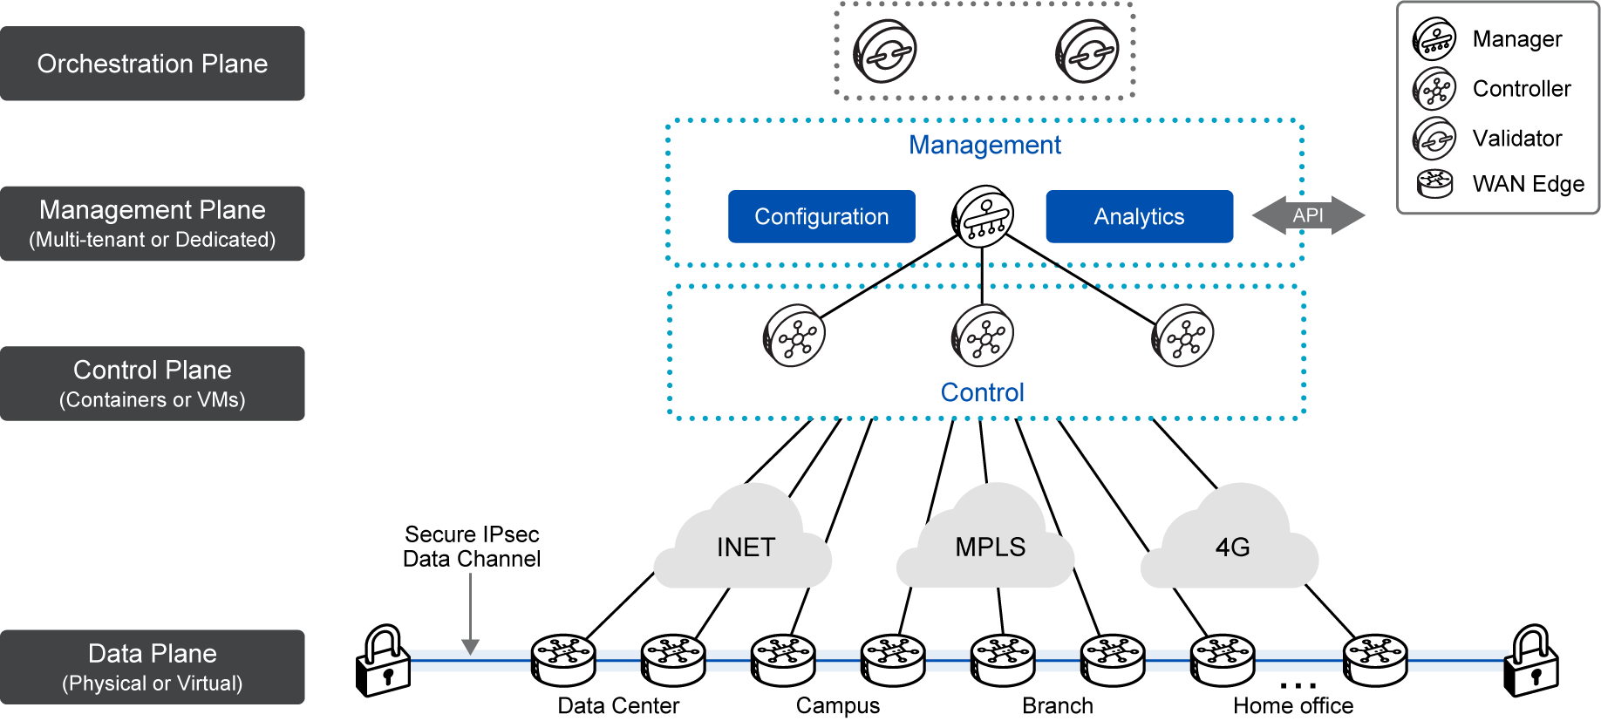
The Cisco Catalyst SD-WAN fabric, or overlay network, creates a software layer. This layer operates seamlessly over any standard transport service. This includes the public Internet, MPLS, 5G/LTE, and satellite. This transport independence lets your company use diverse and cost-effective connectivity. At the same time, it maintains consistent policy enforcement and high performance across your network.
 | Tip: The fundamental shift of Cisco Catalyst SD-WAN is moving from a hardware-centric, manual approach to a secure, software-defined, and policy-driven virtual IP fabric. This abstraction of complexity is key to its agility and intelligence.

Key Advantages and Business Value
Cisco Catalyst SD-WAN directly addresses the limitations of traditional WANs you identified. It offers compelling advantages that translate into significant business value for your company:
Agility
Enhanced Business Agility: Cisco Catalyst SD-WAN is a cloud-delivered overlay WAN architecture. It facilitates digital and cloud transformation for enterprises like yours. It significantly reduces deployment time for new services and locations. What once took months can now take days or hours, thanks to automation and centralized control. This enhanced agility allows your organization to respond quickly to market changes. You can expand operations rapidly and integrate new technologies with unprecedented speed, gaining a competitive edge.
The following icon represents how Cisco Catalyst SD-WAN accelerates change and boosts business agility.

Real-World Scenario: Your leadership team is pushing for digital transformation, including increased cloud adoption and a more agile IT infrastructure. You need to articulate how Cisco Catalyst SD-WAN directly supports these business goals by overcoming the limitations of your legacy WAN, framing your arguments for your upcoming presentation.
Why it Matters: Enhanced business agility means that your company can quickly seize new market opportunities. It accelerates digital transformation initiatives and ensures that you stay competitive in a fast-paced environment.
Engineer Insight: When presenting to management, frame technical benefits (such as centralized control, application-aware routing) in terms of business value (such as faster application deployment, reduced operational expenses). This bridges the gap between engineering and executive priorities. Quantifying these benefits will be key to convincing your executive audience during the presentation.
Simplified
Simplified Management: A unified, intuitive management console replaces traditional WAN complexity. The Cisco Catalyst SD-WAN Manager offers a centralized platform for all network operations. It streamlines configuration, monitoring, and troubleshooting. This drastically cuts operational costs and reduces human error. This 'single pane of glass' approach simplifies Day 0, Day 1, and Day 2 operations. It frees up your IT staff to focus on strategic initiatives.
The following figure shows how Cisco Catalyst SD-WAN simplifies network management.
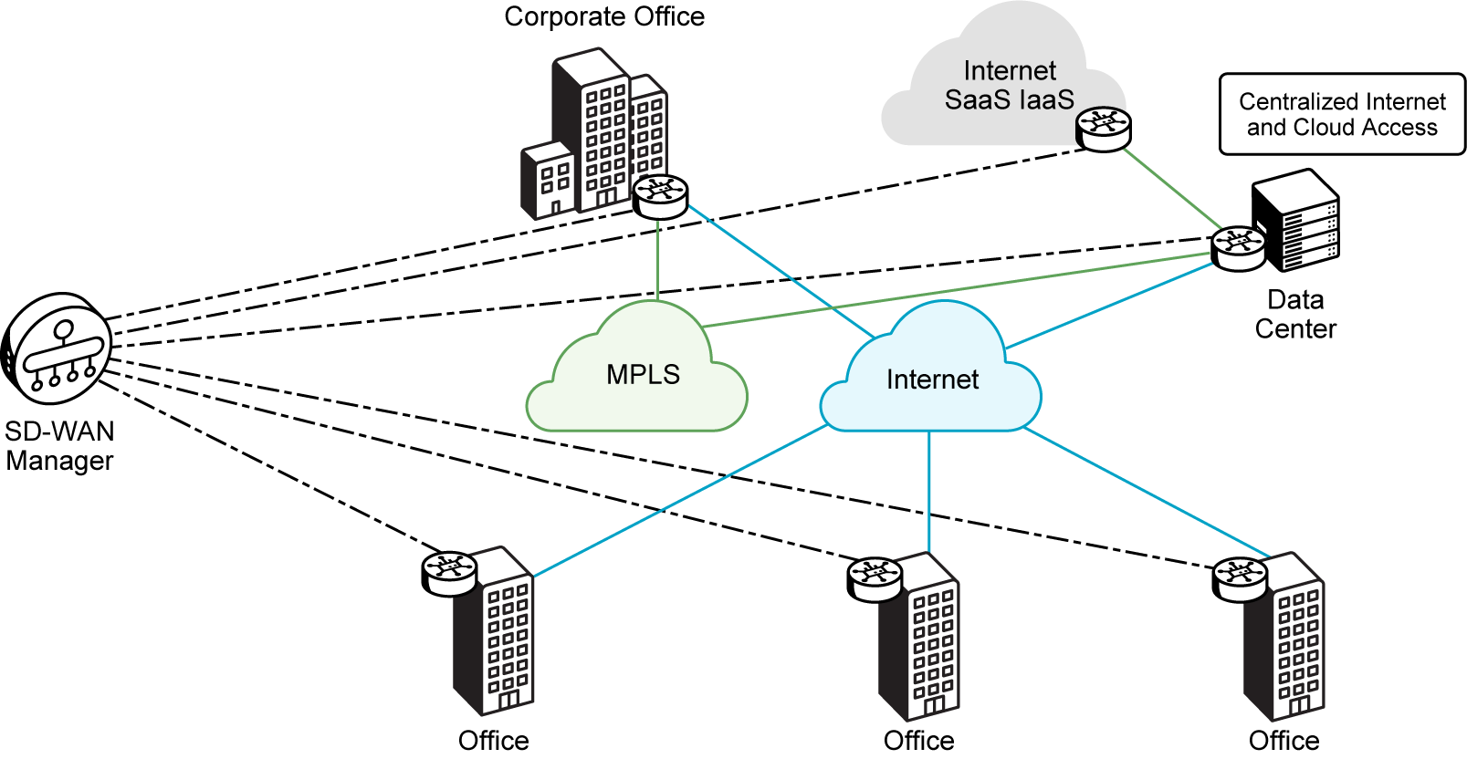
Real-World Scenario: Your IT team currently spends days manually configuring new branch routers. With Cisco Catalyst SD-WAN Manager, a new branch can be onboarded and fully operational in hours, freeing up your engineers for strategic projects.
Why it Matters: Simplified management reduces operational overhead. It lowers the risk of configuration errors and allows your IT team to shift from reactive troubleshooting to proactive innovation, driving greater value for the business.
Engineer Insight: Embrace the power of centralized management to shift your focus from repetitive, manual tasks to strategic network design and optimization. By leveraging templates and a single pane of glass, you ensure configuration consistency across the fabric, dramatically reducing troubleshooting time and freeing up resources for innovation.
Secure DIA
Secure Direct Internet Access: In traditional WANs, branch Internet traffic routes through a central data center for security checks. This leads to higher bandwidth use and increased latency that can affect application performance. Direct Internet Access (DIA) addresses this by allowing remote sites to send Internet-bound traffic directly, reducing latency and bandwidth load at the central site. However, DIA introduces security risks, which Cisco Catalyst SD-WAN addresses using embedded security features or integration with Secure Access Service Edge (SASE) solutions like Cisco Umbrella Cloud. These provide comprehensive security and visibility, with support for third-party Secure Internet Gateways such as Zscaler.
The following figure illustrates how SD-WAN enables secure Direct Internet Access at branches.
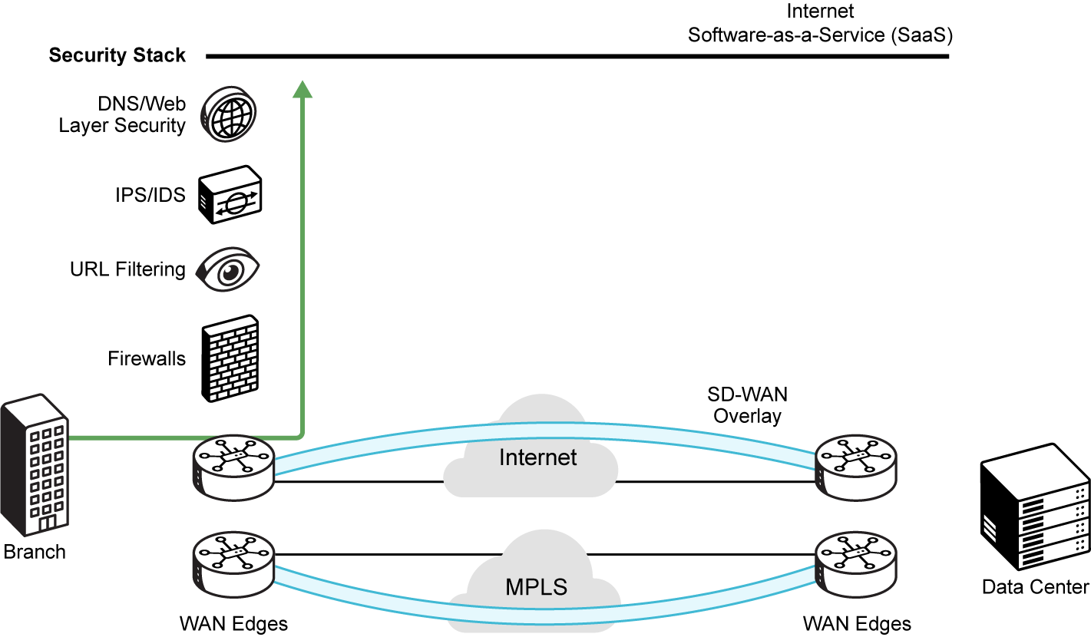
Real-World Scenario: Your CISO is concerned about the increasing threat landscape and the need for consistent security across all distributed locations. Cisco Catalyst SD-WAN's integrated security features, like end-to-end encryption and zero-trust onboarding, address these concerns proactively for your company.
Why it Matters: Robust, integrated security protects your company's sensitive data and intellectual property. It mitigates the risk of costly breaches and ensures compliance with regulatory standards, safeguarding your reputation and financial stability.
Engineer Insight: Security should be an inherent part of the network, not an afterthought. Cisco Catalyst SD-WAN builds a robust, policy-driven security framework directly into the fabric. This ensures strong authentication, data encryption, and consistent policy enforcement from the data center to the branch and cloud.
Application-aware
Intelligent Application Awareness: Cisco Catalyst SD-WAN lets you deploy data and control policies, plus Quality of Service (QoS). This improves speed, security, and performance for your applications. It intelligently identifies applications, often using Deep Packet Inspection (DPI). Then, it steers their traffic over the optimal path. This is based on real-time network conditions and predefined Service Level Agreements (SLAs). This ensures a superior user experience for critical applications. This dynamic traffic steering goes beyond traditional routing, which only focuses on network reachability. Instead, it prioritizes actual application performance.
The following figure demonstrates intelligent path selection based on application needs.
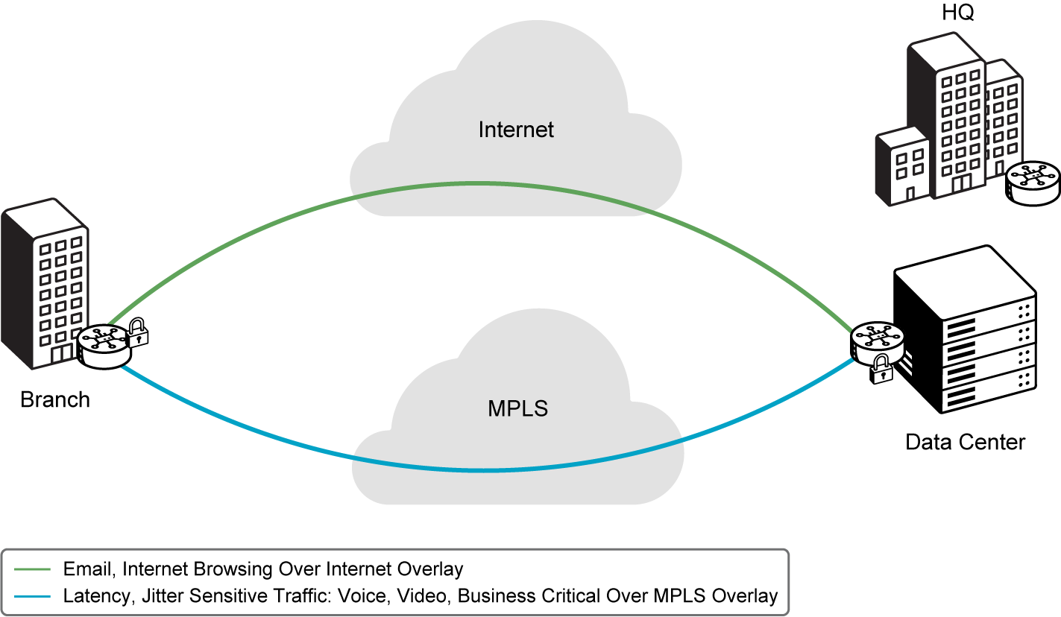
Real-World Scenario: During a critical sales presentation, your video conferencing application experiences glitches. Cisco Catalyst SD-WAN intelligently identifies the video traffic and dynamically steers it over the most stable and low-latency link, ensuring a smooth presentation for your team.
Why it Matters: Intelligent application awareness ensures that your critical business applications always perform optimally. This directly translates to increased employee productivity, better customer experiences, and reliable operation of essential services.
Engineer Insight: Moving beyond simple routing, application-aware routing ensures that business-critical applications (like VoIP, video, or SaaS) always get the best possible path. This is based on their real-time performance needs. This directly translates to a superior user experience and increased productivity for your users.
Cost-Efficient
Improved Cost Efficiency: Cisco Catalyst Cisco Catalyst SD-WAN significantly reduces your WAN costs. It lets your organization use lower-cost internet broadband connections. These can be alongside or in place of expensive MPLS circuits. This multi-transport capability optimizes bandwidth utilization. Combined with simplified management and faster service deployment, this leads to a lower Total Cost of Ownership (TCO). It minimizes both capital and operational expenses for your company.
The following figure highlights how SD-WAN improves cost efficiency by using broadband links.
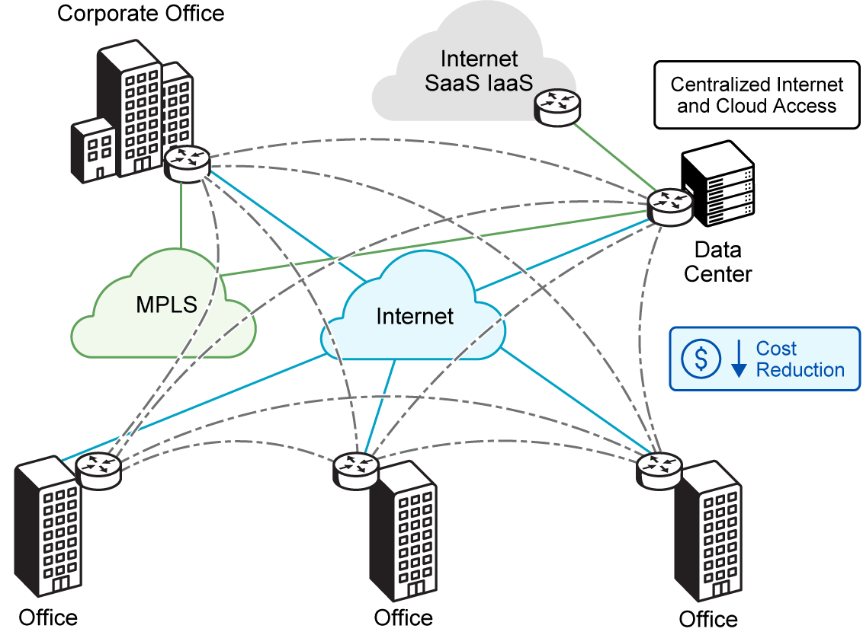
Real-World Scenario: Your finance department is looking to reduce WAN expenditures. By leveraging lower-cost internet broadband connections alongside existing MPLS, Cisco Catalyst SD-WAN allows your company to maintain performance while significantly cutting costs.
Why it Matters: Improved cost efficiency directly impacts your company's profitability. By reducing WAN expenditures, you can reallocate resources to other strategic initiatives, enhancing overall financial health and competitive advantage.
Engineer Insight: The ability to intelligently use a mix of transport services, including affordable internet, is a game-changer for WAN budgets. Cisco Catalyst SD-WAN optimizes bandwidth utilization and reduces reliance on expensive dedicated circuits. This leads to a lower Total Cost of Ownership (TCO) for the entire WAN infrastructure.
1. Which of the following Cisco Catalyst SD-WAN advantages directly addresses the challenges of slow provisioning and complex manual configurations in traditional WANs?
A. Secure Direct Internet Access
B. Enhanced Business Agility and Simplified Management
C. Intelligent Application Awareness
D. Improved Cost Efficiency
2. Your company's finance team is looking to significantly reduce WAN expenditures. Which core benefit of Cisco Catalyst SD-WAN would you highlight as the primary driver for improved cost-efficiency?
A. Its capacity to leverage lower-cost internet broadband connections alongside or in place of expensive MPLS circuits.
B. Its integrated security features, including end-to-end encryption.
C. Its ability to intelligently identify and prioritize critical applications.
D. Its centralized management console for streamlined operations.
SD-WAN Benefits at a Glance
Cisco Catalyst SD-WAN empowers your business with greater agility, cost efficiency, superior performance, and secure direct internet access—transforming your network for the demands of today’s digital enterprise:
Agility
Agility - Cisco Catalyst SD-WAN significantly enhances business agility by enabling:
Faster Provisioning: Rapid deployment of new services and locations.
Rapid Branch Expansion: Quick onboarding of new branch offices.
Quick Service Integration: Seamless integration of new technologies and cloud apps.
Cost
Cost Efficiency - Cisco Catalyst SD-WAN drives improved cost-efficiency through:
Lower Circuit Costs: Leveraging affordable internet broadband alongside MPLS.
Reduced Operational Expenses: Streamlined management and automation.
Optimized Bandwidth Use: Efficient utilization across diverse transports.
Performance
Performance - Cisco Catalyst SD-WAN delivers superior network performance via:
Improved Application Experience: Optimized paths and QoS for critical apps.
Dynamic Path Selection: Real-time routing based on SLAs and network conditions.
Reduced Latency: Traffic steering to avoid congestion and suboptimal routes.
Secure DIA
Secure Direct Internet Access - Cisco Catalyst SD-WAN enables secure direct internet access by:
Reducing Central Site Traffic: Allowing branches to send internet-bound traffic directly.
Integrating Security: Using embedded features or SASE solutions like Cisco Umbrella Cloud.
Ensuring Compliance: Providing comprehensive security and visibility for remote users.
 | Think Like an Engineer: Benefits of Cisco Catalyst SD-WAN  How would you explain the benefits of Cisco Catalyst SD-WAN to a CIO vs. a junior engineer?  - When articulating SD-WAN value to executive stakeholders, focus on quantifiable benefits relatable to ROI such as cost reduction, increased agility, and improved user productivity.

 | Key Takeaway: Transforming Your WAN for Business Value  Cisco Catalyst SD-WAN offers a comprehensive, cloud-delivered overlay WAN architecture. It directly addresses the fundamental limitations of traditional WANs you've encountered.  By adopting SD-WAN, your company can achieve:  - Enhanced Business Agility: Rapidly deploy new services and locations, responding quickly to market changes.  - Simplified Management: Centralize control, reduce operational costs, and minimize human error.  - Secure Direct Internet Access: Reduce central site traffic and cut latency by letting branches access the internet directly while integrated security, either at the branch or via SASE, protects users from online threats and maintains compliance.  - Improved Cost-Efficiency: Reduce WAN expenditures by leveraging diverse, lower-cost transport options.  This enables your organization to build a highly responsive, securely connected, and cost-efficient network that meets the demands of modern application delivery and supports your distributed workforce.

Underlay vs. Overlay Architecture
At the heart of Cisco Catalyst SD-WAN's transformative power lies a fundamental architectural shift. It separates your network into two distinct layers: the underlay and the overlay. This innovative design gives SD-WAN its agility, flexibility, and enhanced security. To design, deploy, or manage a Cisco Catalyst SD-WAN solution, you must understand the roles and interdependencies of these two layers.
 | Now let's examine the underlay and overlay and define their complementary relationship.You will also see how the overlay abstracts your physical network's complexities to deliver an intelligent, policy-driven WAN.

The Underlay Network: The Foundation
The underlay network is your foundational, physical network infrastructure. Think of it as your network's raw plumbing, or its physical roads and highways. Its main job is to provide basic IP connectivity and reachability between network devices. This is especially true for the WAN edge routers that define the perimeter of your SD-WAN sites. It is the network that carries the packets.
The following figure shows the underlay network, which provides the physical IP connectivity between data center, campus, and branch sites.
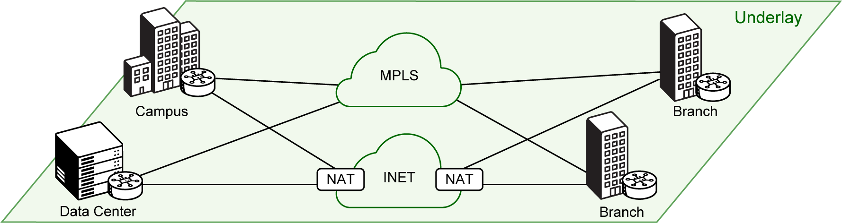
Key Characteristics of the Underlay:
The underlay network provides the foundational physical and logical infrastructure that supports reliable connectivity, traditional routing, and secure VPN services across your organization:
Infrastructure
Physical Infrastructure
Explanation: This includes physical routers, switches, cables, and links (e.g., MPLS circuits, internet broadband, 5G/LTE connections). It is the actual hardware and cabling.
Analogy: Think of this as the literal roads, bridges, and tunnels of your network. It's the tangible stuff you can touch and see (or at least visualize) that physically carries the data. It's the raw material upon which everything else is built.
The following figure illustrates the physical infrastructure that forms the underlay network.
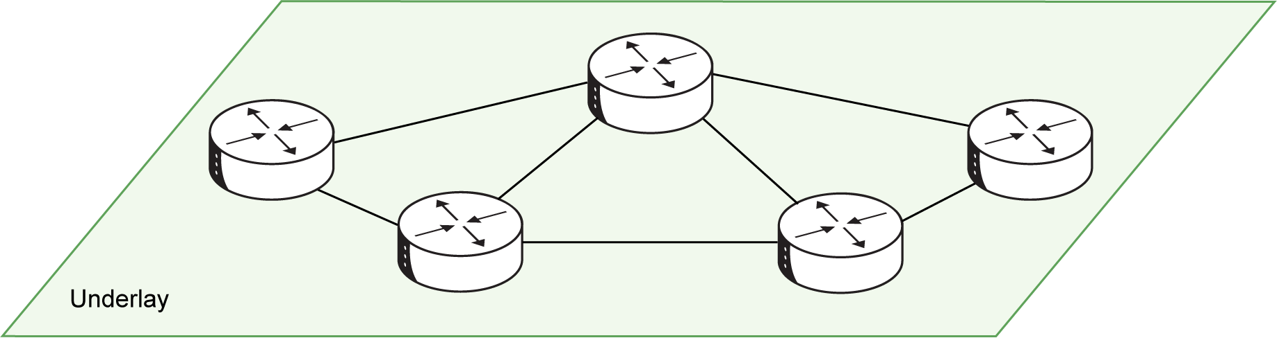
Connectivity
Basic Connectivity
Explanation: Its sole responsibility is to transport packets between WAN Edge devices. It needs to know routes to the next-hop or destination router. However, it does not concern itself with specific network prefixes behind those routers in their local service networks (e.g., LAN segments).
Analogy: This is like a postal service that only delivers between major sorting facilities (your WAN Edge devices). The postal service knows how to get a package from one facility to another, but it doesn't care about the specific street address within the town once it reaches the destination facility. Its job ends at the next major hub.
The following figure shows how the underlay provides basic IP connectivity between WAN Edge devices.
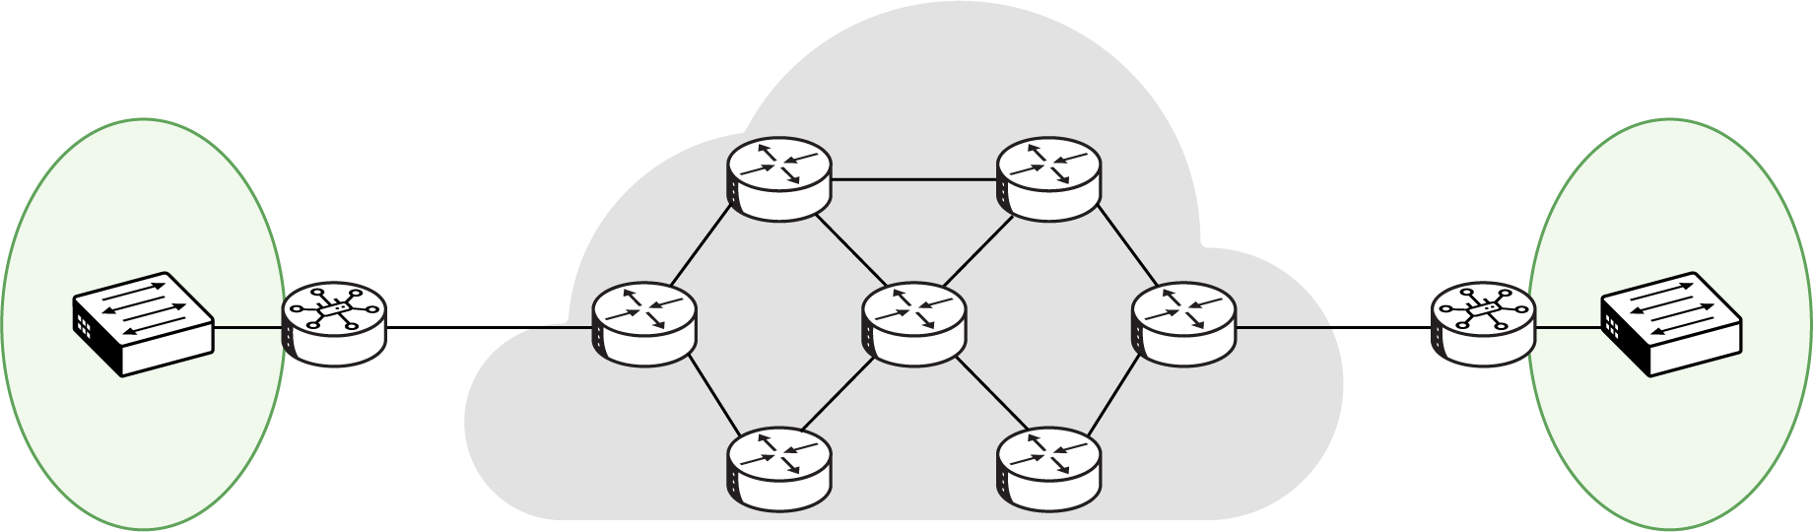
Routing
Traditional Routing
Explanation: It uses conventional routing protocols (e.g., OSPF, BGP, static routes) to establish reachability within its own domain. The underlay operates with its own routing logic, independent of the overlay's policies.
Analogy: This is the local traffic control system within the road network. Each intersection (router) knows how to direct vehicles (packets) to the next intersection or major exit. It follows its own set of rules (OSPF, BGP) for efficient traffic flow, without needing to know the final destination of every individual car (application traffic).
The following figure demonstrates how traditional routing protocols operate within the underlay network.
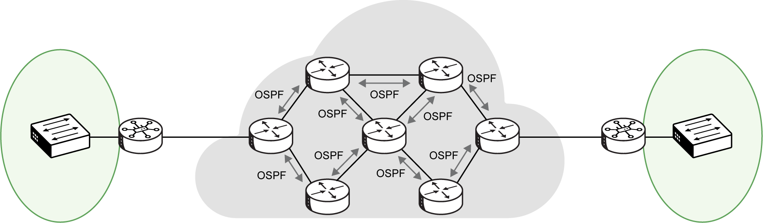
VPN 0
VPN 0
Explanation: In Cisco Catalyst SD-WAN, network ports connected to the underlay are part of VPN 0, the transport VPN. This VPN carries all control plane traffic among your Cisco Catalyst SD-WAN devices (Controllers, Manager, WAN Edges). It also acts as the conduit for building overlay tunnels. It is a special VPN dedicated to transport.
Analogy: Consider this a dedicated "service lane" or "maintenance tunnel" on your highway system. Only essential service vehicles (SD-WAN control traffic) use this lane. It's crucial for building and managing the main traffic routes (overlay tunnels) and ensuring the system operates, but regular passenger cars (user data) don't use it directly.
The following figure illustrates VPN 0, the transport VPN used for SD-WAN control and tunnel establishment.
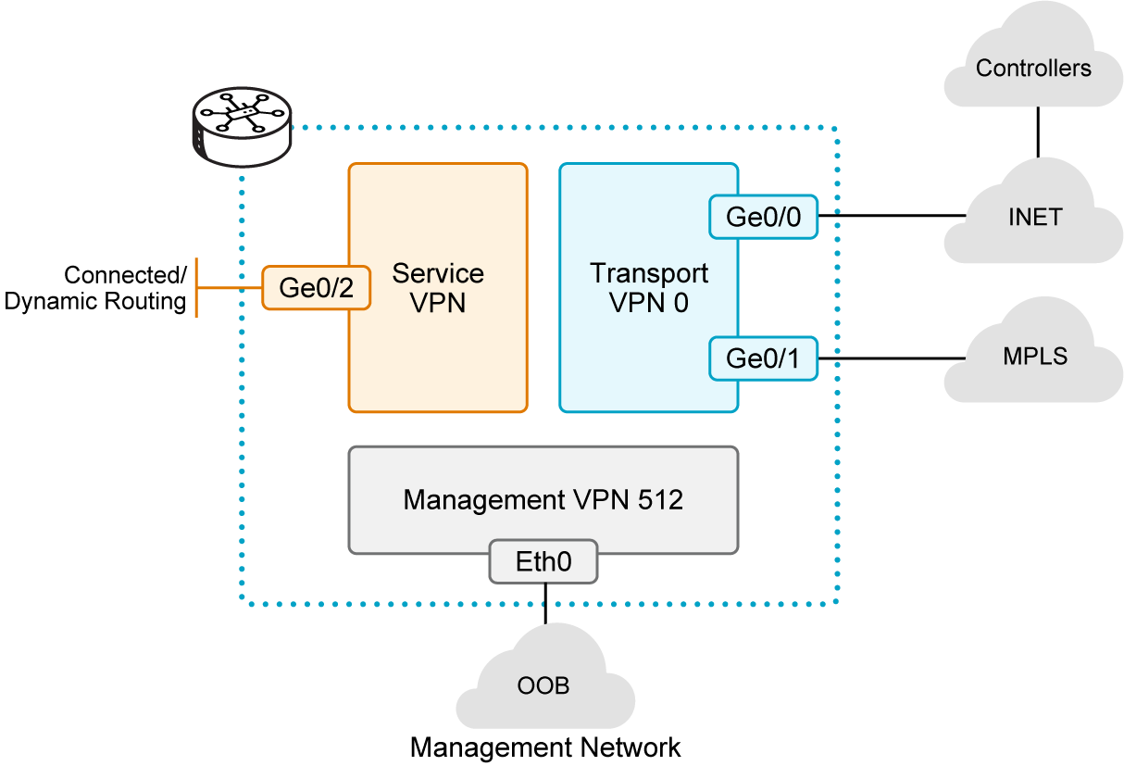
Real-World Scenario: Bridging the Conceptual Gap for Leadership
Your leadership team is struggling to visualize how a 'software-defined' network actually works. They understand physical connections like MPLS circuits but are confused by the idea of a 'virtual fabric' that runs over them. You need to clearly articulate how Cisco Catalyst SD-WAN separates the physical network (the underlay) from the intelligent, policy-driven network (the overlay) in a way that highlights its flexibility and security benefits, without getting lost in technical jargon. This conceptual hurdle is delaying buy-in for your modernization plan.
Why it Matters: The underlay is the indispensable physical foundation for any SD-WAN deployment. Its inherent stability, performance, and proper configuration are critical, as they directly dictate the reliability and quality of the intelligent overlay network built upon it. A robust underlay is essential for leveraging diverse transport options and for you to effectively communicate how this foundational layer supports the advanced capabilities of SD-WAN, securing leadership buy-in.
Engineer Insight: Think of the underlay as the physical roads and the overlay as the GPS navigation system. Your job as an engineer is to ensure the roads are built (underlay connectivity) so that the GPS can intelligently route traffic (overlay intelligence). When explaining this to leadership, clearly articulate that a well-maintained underlay is the non-negotiable prerequisite for all SD-WAN's "smarts." This clarity will build confidence and secure their understanding of the fundamental infrastructure supporting the new, agile network. When troubleshooting connectivity, always check your transport interfaces (VPN0) for basic IP connectivity first; a broken underlay means a non-functional overlay.
1. Which of the following best describes the primary role of the underlay network in a Cisco Catalyst SD-WAN deployment?
A. To enforce intelligent policy and application-aware routing.
B. To provide basic IP connectivity and reachability between physical network devices.
C. To establish encrypted tunnels for application traffic.
D. To manage the centralized control plane of the SD-WAN fabric.
The Overlay Network: The Intelligent Fabric
The overlay network, also called the SD-WAN fabric or virtual IP fabric, is a logical, software-defined network. It builds on top of your underlay. It hides the complexities of the underlying physical network. It also provides the intelligence, policy enforcement, and application-aware routing that define SD-WAN.
 | Think Like an Engineer: Designing the "Smart Navigation System"  You established the underlay network – your physical roads. Now, what is your next task?  - It is time to design the "smart navigation system" (the overlay) that runs on top of the overlay.  - What critical capabilities must the overlay provide to transform raw connectivity into an intelligent, policy-driven, and secure WAN?

Key Characteristics of the Overlay
The overlay network leverages virtual tunnels and centralized intelligence to abstract underlying transport, enabling flexible, policy-driven connectivity, dynamic path selection, and enhanced scalability and security.
Tunnels
Logical Network of Tunnels: The core of the overlay is a mesh of secure, encrypted tunnels (IPsec) established between WAN edge routers across the underlay. These tunnels form the "virtual connections" that carry application data, providing a secure and flexible path.
The following figure illustrates how the overlay forms secure tunnels over the underlay.
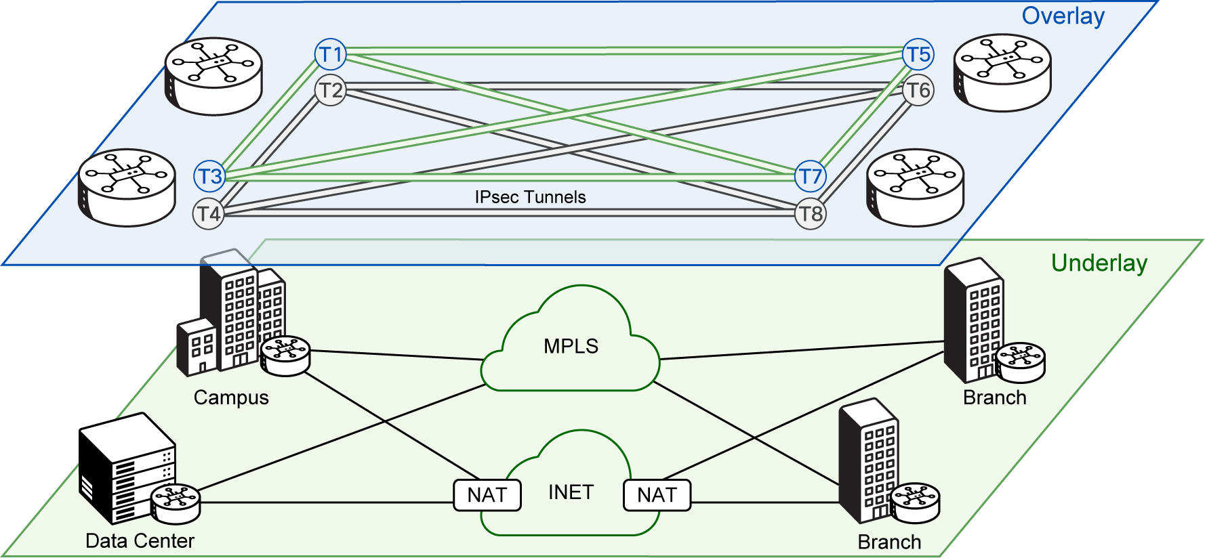
Real-World Scenario: Your security team needs assurance that all data traversing the WAN, even over public internet links, is fully encrypted and protected from eavesdropping.
Why it Matters: These tunnels provide the fundamental secure transport for all application data within the SD-WAN fabric, ensuring confidentiality and integrity over any underlying network.
Engineer Insight: Think of these tunnels as secure, private pipelines built over public infrastructure. They abstract the underlying transport, allowing you to focus on what's inside (application data) rather than the physical medium.
Control
Centralized Control: The overlay is orchestrated by the SD-WAN Controllers, which serve as the centralized brain. They distribute policies, routing information, and security parameters across the overlay, eliminating the need for complex, distributed configurations on every device. This centralization simplifies management and ensures consistency.
The following figure depicts how SD-WAN controllers centrally manage the overlay.
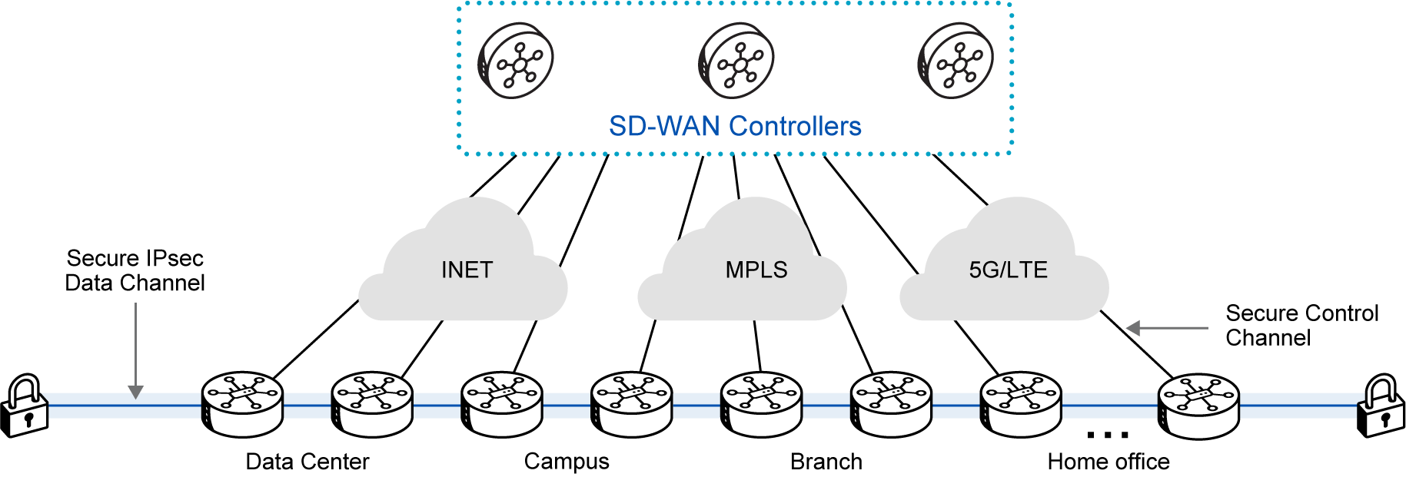
Real-World Scenario: You need to make a networkwide routing change that affects all 100 branch offices. In a traditional WAN, this would mean touching every router individually.
Why it Matters: Centralized control drastically reduces operational complexity and human error by allowing a single point of management for routing and policy distribution across the entire network.
Engineer Insight: This is like having one overall switchboard for all network decisions. You configure once, and the intelligence is distributed, ensuring consistency and making large-scale changes manageable.
Policy
Policy-Driven: All traffic steering, security enforcement, and application optimization within the overlay are driven by centralized policies configured in Cisco Catalyst SD-WAN Manager. This allows for granular control over how applications behave and are prioritized across the WAN, aligning network behavior with business intent.
The following figure shows how centralized policies drive overlay behavior.
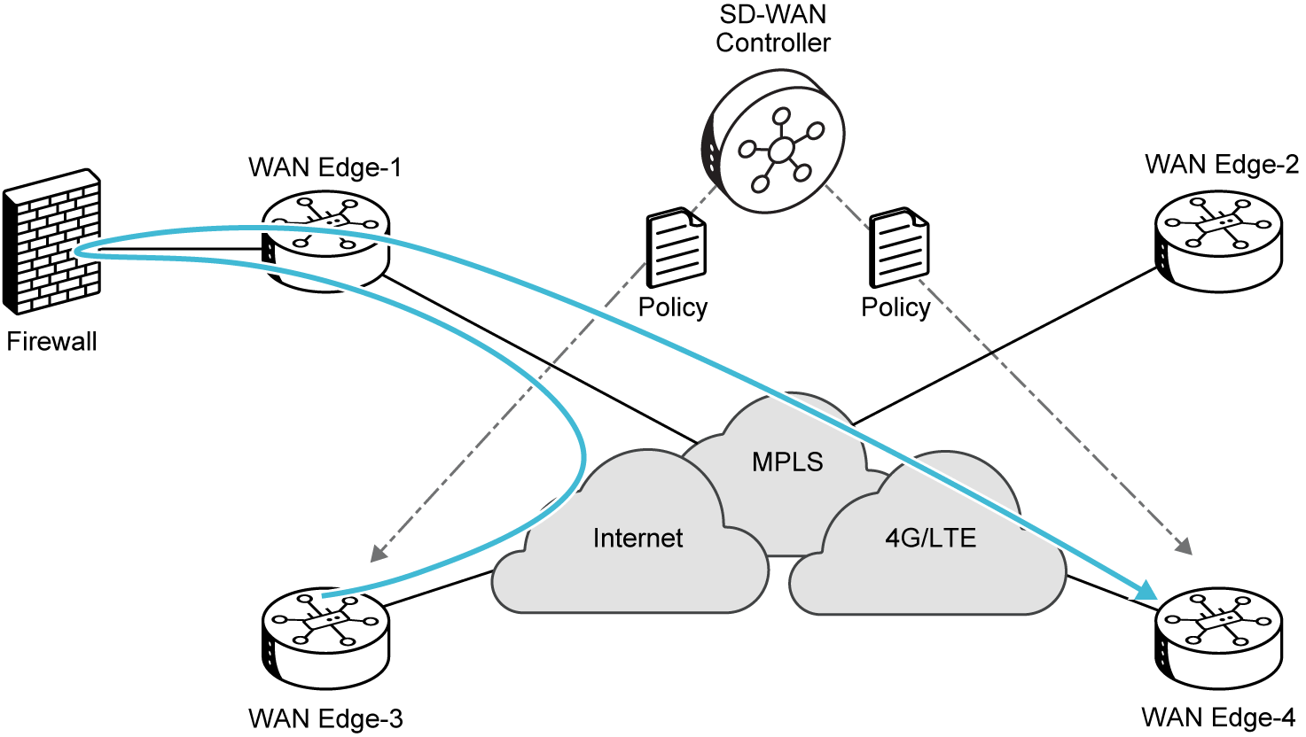
Real-World Scenario: Your finance department needs all their application traffic to use the "gold" (MPLS) link, while guest Wi-Fi traffic can use the "bronze" (Internet) link.
Why it Matters: Policy-driven management allows the network to align directly with business objectives, automatically enforcing rules for traffic steering, security, and application performance based on predefined intent.
Engineer Insight: You're defining 'what' the network should do for the business, not 'how' each device should do it. This declarative approach ensures that your network behaves exactly as business needs dictate, without manual adjustments per device.
Abstract
Underlay Abstraction: The overlay shields the applications and users from the intricacies of the underlay. It doesn't matter if the underlay uses MPLS, Internet, or a mix; the overlay provides a consistent, secure, and policy-driven service, making the underlying transport transparent to applications.
The following figure illustrates how the SD-WAN overlay abstracts the complexity of the underlay transports.

Real-World Scenario: Your company is transitioning from MPLS to a hybrid WAN with broadband internet, but you don't want application performance or user experience to be negatively impacted by the underlying transport changes.
Why it Matters: Abstraction allows the SD-WAN fabric to operate consistently over any mix of transports, providing flexibility and future-proofing your network without requiring application re-architecture.
Engineer Insight: The overlay makes the 'pipes' underneath irrelevant to the 'water' flowing through them. This means you can swap out or mix transports without re-engineering your application delivery strategy.
Dynamic
Dynamic Path Selection: The overlay continuously monitors the performance of the underlying transport links (using protocols like BFD) and can dynamically steer application traffic over the optimal path in real-time to meet SLA requirements. This ensures the best user experience even during network degradation.
The following figure illustrates dynamic path selection based on real-time link performance.
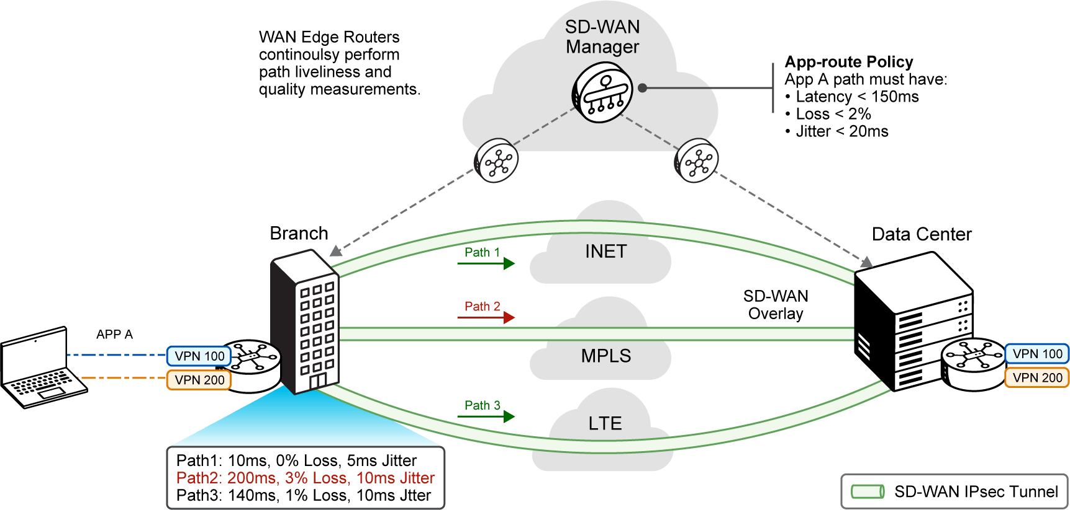
Real-World Scenario: Your VoIP calls are experiencing jitter during peak hours due to congestion on one of your internet links, but you have a less utilized MPLS link available.
Why it Matters: Dynamic path selection ensures that critical applications always use the best available network path, automatically adapting to real-time network conditions to maintain performance and user experience.
Engineer Insight: This is your network's 'autopilot.' Instead of static routes, traffic is intelligently rerouted around congestion or outages, often before users even notice a problem.
Scalable
Scalability and Security: By centralizing routing intelligence and security functions (like dynamic key exchange for IPsec tunnels), the overlay dramatically simplifies the scaling of the network and inherently builds in strong security, including end-to-end encryption and authentication.
The following figure highlights how the overlay fabric scales securely.
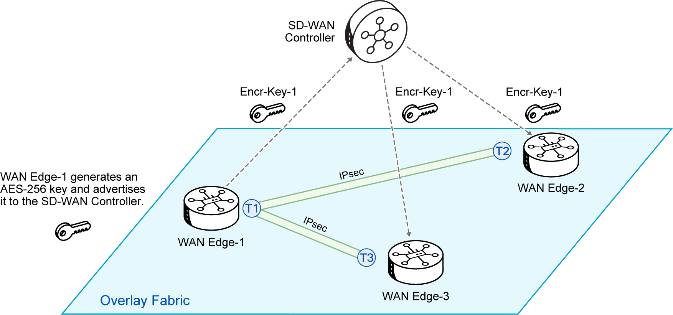
Real-World Scenario: Your company is growing rapidly, adding new branches monthly, and needs to ensure that every new site is instantly secure with encrypted communications and authenticated devices.
Why it Matters: The overlay's architecture is designed for rapid, secure expansion, allowing you to scale your network efficiently while maintaining robust, built-in security from day one.
Engineer Insight: Security and scalability are baked in, not bolted on. You don't need to re-architect your security posture every time you add a new site; the fabric extends its protections automatically.
2. Which of the following is a key characteristic of the overlay network in Cisco Catalyst SD-WAN?
A. It is composed solely of physical routers and links.
B. Its primary function is to provide basic IP reachability between devices.
C. It operates independently without any reliance on the underlay network.
D. It is a logical network of encrypted tunnels responsible for intelligent policy enforcement.
The Complementary Relationship: How the Underlay and Overlay Work Together
The underlay and overlay are interdependent. The underlay provides the essential connectivity, while the overlay builds on that foundation to create an intelligent, secure, and adaptable network. Together, they enable the agility and control of SD-WAN:
Underlay
Underlay Provides Reachability: Your WAN edge routers use the underlay to establish basic IP connectivity to each other and to the SD-WAN Controllers. This foundational connectivity is essential for the overlay to form.
Overlay
Overlay Builds Tunnels: Over this underlay connectivity, your WAN Edge routers establish secure IPsec tunnels to other WAN Edge routers. The SD-WAN Controllers help exchange necessary information (like encryption keys). This builds these tunnels and hides the underlay's complexities.
Data Flow
Data Flows Securely: Your application traffic then flows securely and intelligently over these encrypted overlay tunnels. Policies distributed by the SD-WAN Controllers guide this traffic. The overlay intelligently steers traffic across the underlay's available paths.
This separation lets you influence router-to-router communication (underlay) independently. You can also influence communication between users or hosts (overlay). This provides unprecedented control and flexibility. This dual-layer approach gives Cisco Catalyst SD-WAN its power and adaptability.
The following figure demonstrates how the underlay and overlay operate together.

Real-World Scenario: Your company has a mix of MPLS and internet connections. You need to explain to a new team member how SD-WAN uses both to create a single, unified network. You'll describe how the physical links (underlay) provide the basic paths, and then how the SD-WAN fabric (overlay) builds secure, intelligent tunnels over those diverse paths to deliver consistent application performance.
Why it matters: Understanding the symbiotic relationship between the underlay and overlay is fundamental to appreciating how Cisco Catalyst SD-WAN delivers its core benefits. It clarifies how physical infrastructure is leveraged by intelligent software to create a highly adaptable and secure network.
Engineer Insight: When troubleshooting, remember the "two layers." If your overlay tunnels aren't forming, first check the underlay. Is there basic IP reachability? Can your WAN Edge devices ping each other over the transport networks? Once underlay connectivity is confirmed, then investigate overlay-specific issues like control plane communication (OMP) or policy distribution.
Tip: The Cisco Catalyst SD-WAN underlay and overlay are interdependent. Think of the underlay as providing the foundational physical connectivity, while the overlay builds on that foundation to create an intelligent, secure, and adaptable network. This synergy enables the agility and control of the entire Cisco Catalyst SD-WAN solution.

3. In Cisco Catalyst SD-WAN, what is the primary function of the underlay network in relation to the overlay network?
A. To provide basic IP connectivity over which the overlay tunnels are built.
B. To provide the intelligence for dynamic path selection.
C. To establish encrypted tunnels for application traffic.
D. To distribute security policies to WAN Edge devices.
Underlay/Overlay Key Terms
Explore these essential terms to better understand the core components and functions of SD-WAN architecture.
Underlay Network | The physical network infrastructure providing basic IP connectivity.
Overlay Network | A logical, software-defined network built on the underlay, providing intelligent, policy-driven services via encrypted tunnels.
VPN 0 | The transport VPN in Cisco Catalyst SD-WAN that carries control plane traffic and connects to the underlay.
IPsec Tunnels | Secure, encrypted tunnels forming the core of the overlay network, carrying application data.
BFD (Bidirectional Forwarding Detection) | Protocol used by the overlay to continuously monitor the performance and liveliness of underlay transport links.
SD-WAN Controllers | Centralized brain of the overlay, orchestrating policies, routing information, and security parameters.
SD-WAN Manager | Unified management console for configuring, monitoring, and troubleshooting the SD-WAN fabric.
SD-WAN Validator | The first point of contact for new devices, responsible for initial authentication and facilitating NAT traversal.

 | Think Like an Engineer: Abstracting the Underlay  How does abstracting the underlay simplify network design and operations in a large enterprise?  - Consider aspects like transport independence, policy consistency, and simplified troubleshooting.

Overlay Tunnel Construction: Step-by-Step
To understand how the intelligent overlay network is formed, let's walk through the step-by-step process of secure tunnel construction.
Step 1
Step 1 - Underlay Reachability: Before any overlay tunnels can form, your WAN edge routers must have basic IP connectivity over the underlay network. This means that they can reach each other's transport interfaces (part of VPN 0) via MPLS, Internet, or other physical links.
The following figure illustrates Step 1 of overlay tunnel construction: ensuring basic underlay reachability.
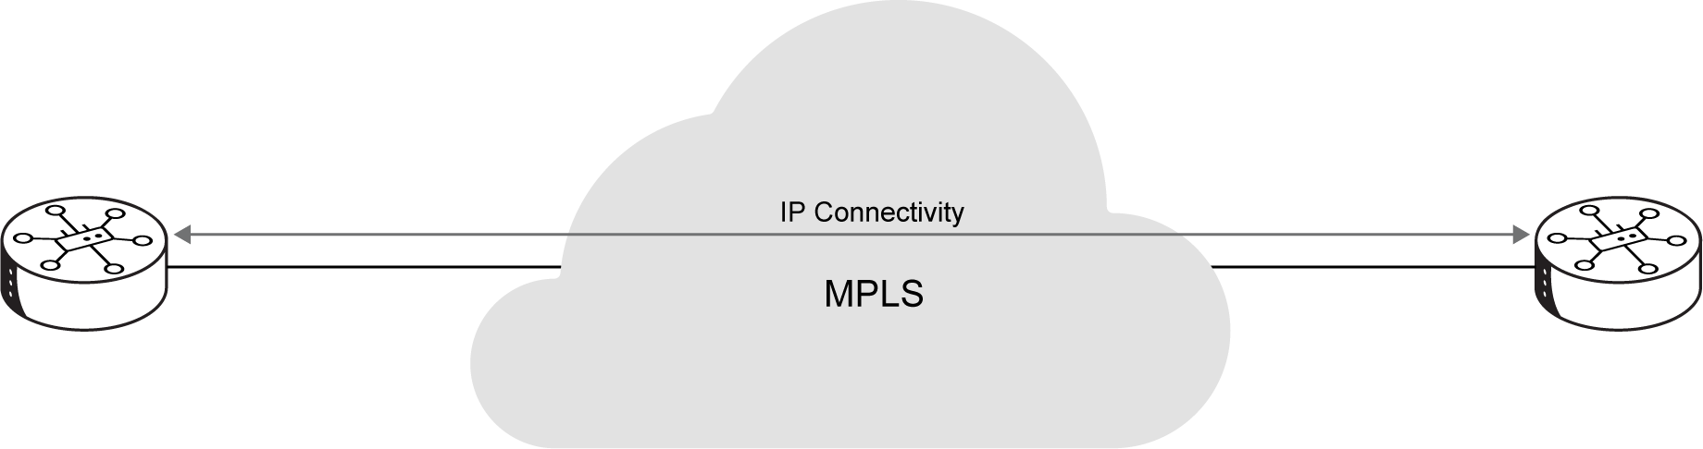
Step 2
Step 2 - Control Plane Exchange (OMP): Once underlay reachability is established, your WAN Edge routers connect to the centralized SD-WAN Controllers. The Controllers then help exchange necessary information. This includes encryption keys. This happens via the Overlay Management Protocol (OMP).
The following figure illustrates Step 2 of overlay tunnel construction: exchanging control-plane information using OMP.
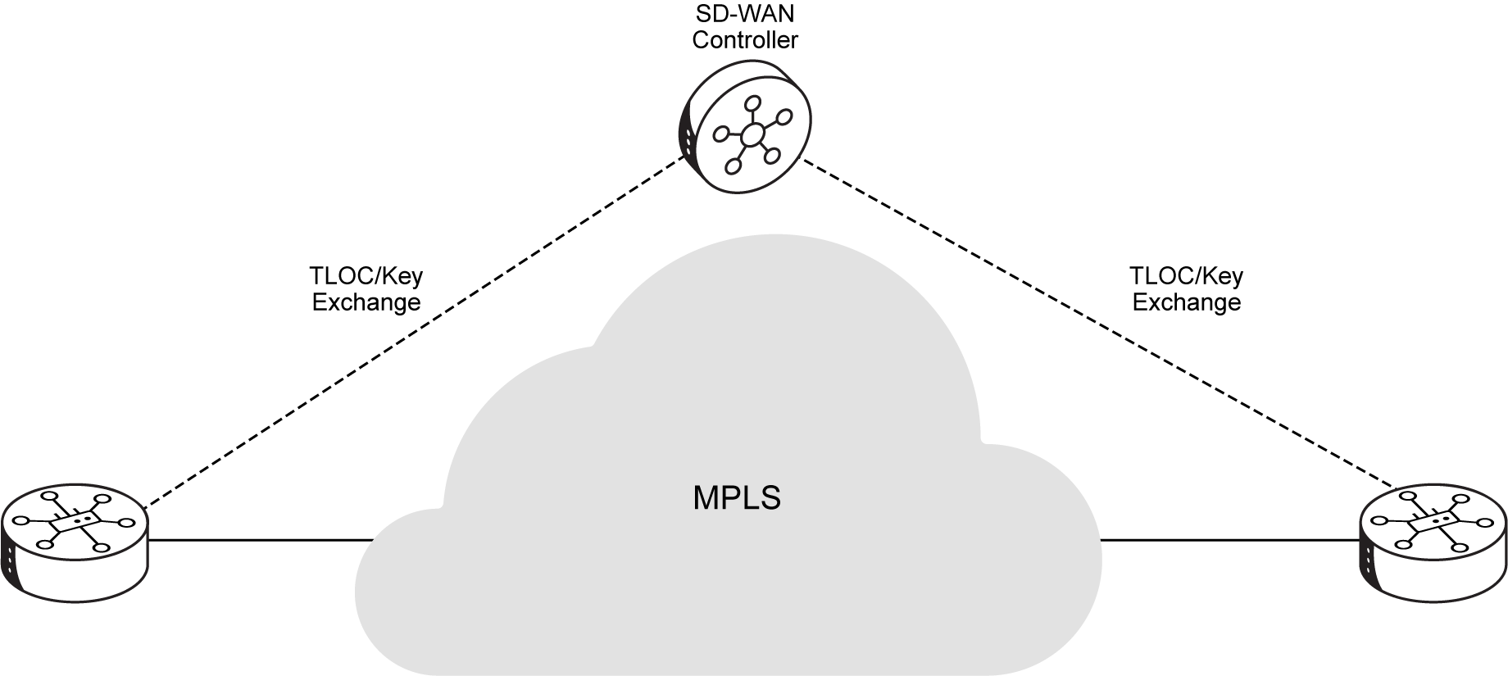
Step 3
Step 3 - IPsec Tunnel Establishment: With TLOCs and keys exchanged, your WAN Edge routers can now establish secure, encrypted IPsec tunnels directly between themselves over the underlay connections. These tunnels form the logical paths of your overlay network.
The following figure illustrates Step 3 of overlay tunnel construction, where IPsec tunnels are established between WAN Edge routers.
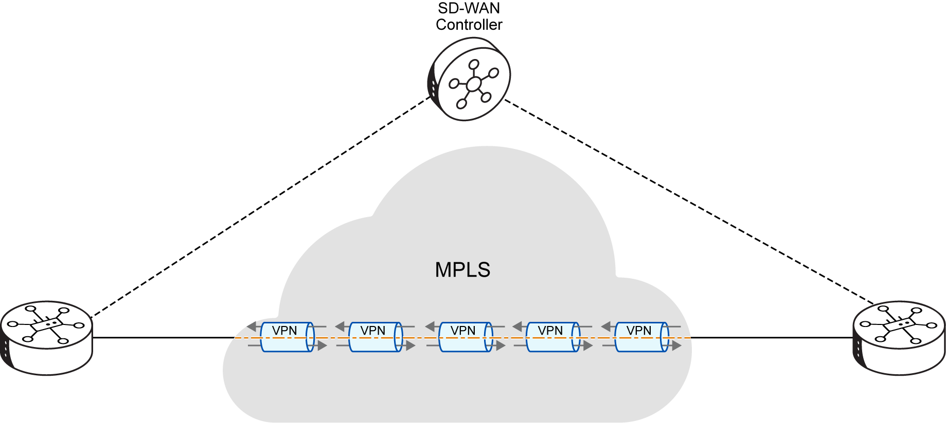
Step 4
Step 4 - Data Flow: Finally, your application traffic flows securely and intelligently over these newly formed IPsec tunnels. The overlay network abstracts the underlay's complexities. This allows traffic to be steered dynamically. It is based on policies and real-time network conditions.
The following figure illustrates Step 4 of overlay tunnel construction, when application data begins to flow across the IPsec tunnels.
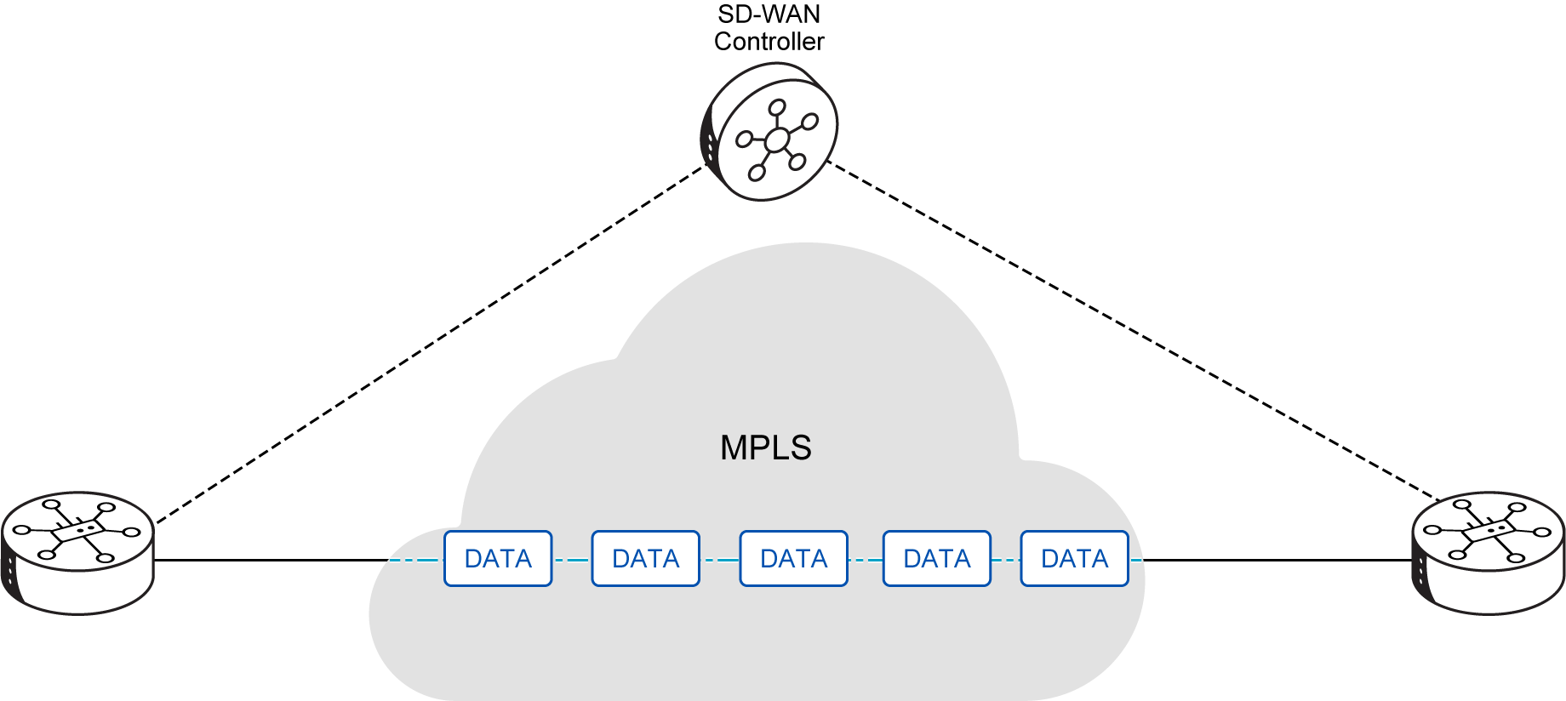
 | Key Takeaway: Your Company's Agile SD-WAN Foundation  The underlay and overlay architecture is fundamental to Cisco Catalyst SD-WAN's power.  By leveraging this dual-layer approach, your company can:  - Separate Concerns: Distinguish between the physical transport (underlay) and the intelligent, policy-driven network services (overlay).  - Leverage Diverse Transports: Build a flexible, secure overlay fabric over any combination of physical links (MPLS, Internet, LTE).  - Achieve Intelligence and Control: Enable dynamic traffic steering, application-aware routing, and centralized policy enforcement, independent of the underlying infrastructure.  - Simplify Operations: Abstract network complexities, making your network easier to manage, scale, and troubleshoot.  This equips your modern enterprise with the adaptability and granular control needed to thrive in a dynamic networking landscape.

Intelligent Control Principles
You now understand the fundamental architectural shifts of Cisco Catalyst SD-WAN. Next, let's examine its core principles—the foundational pillars that enable its transformation and collectively define its agility, security, and intelligence for your company.
 | This topic focuses on the foundational intelligent control principles of Cisco Catalyst SD-WAN. Let's explore how each principle addresses modern networking challenges and contributes to a more efficient, secure, and user-friendly WAN experience for your organization.

The core principles guiding the Cisco Catalyst SD-WAN fabric covered in this topic include:
- Intelligent Routing (powered by OMP)
- Network Segmentation (via VPNs)

The Foundational Pillars of Cisco Catalyst SD-WAN
Cisco Catalyst SD-WAN represents a paradigm shift. It moves from hardware-centric, manually configured networks to a software-defined, policy-driven architecture. Several core principles underpin this transformation. They work together to deliver a cohesive and highly effective solution. These principles help your organization overcome the rigidities and inefficiencies of legacy WANs. They facilitate digital transformation, cloud adoption, and support for your distributed workforce. Collectively, they ensure your network is not just a conduit for data. It becomes an intelligent, secure, and responsive platform for your business operations.
The following figure summarizes the foundational pillars that define Cisco Catalyst SD-WAN.
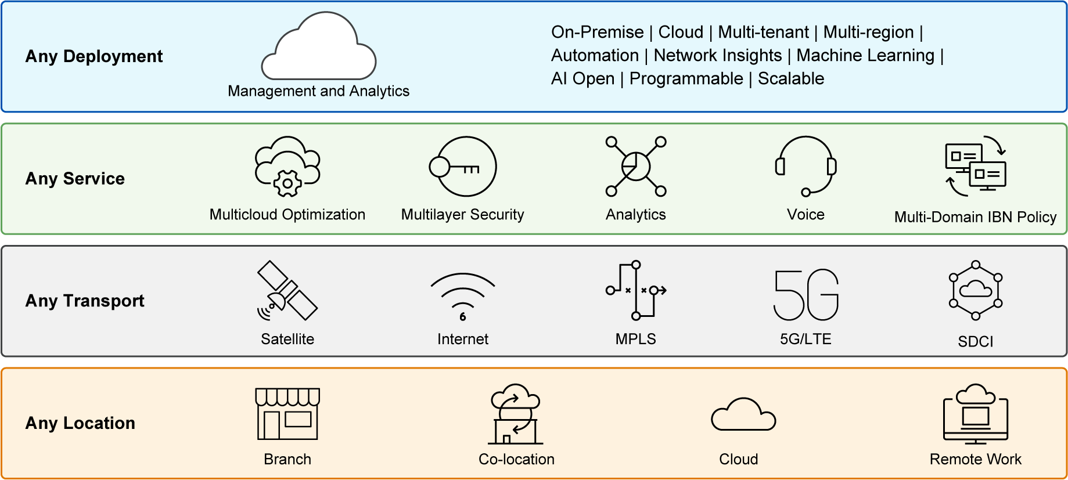
Real-World Scenario: Your enterprise WAN mixes MPLS and VPNs. This leads to high operational costs and application performance inconsistencies. You need to understand how the core principles of Cisco Catalyst SD-WAN can simplify operations, reduce expenses, and improve user experience. This will help you effectively present the solution to your leadership.
Why it matters: These principles collectively define the transformative capabilities of Cisco Catalyst SD-WAN. Understanding them provides you with a framework for designing, deploying, and optimizing a modern, agile, and secure WAN for your company.
Engineer Insight: Each of these principles represents a powerful tool in your Cisco Catalyst SD-WAN toolkit. Learn how they interoperate to deliver a cohesive solution, rather than viewing them as isolated features. For example, Zero Touch Provisioning (ZTP) is great, but it relies on proper Centralized Policy Management and Integrated Security to securely onboard devices. Gaining a deep understanding of how these principles interoperate will allow you to confidently articulate the comprehensive solution to your audience.
Tip: Cisco Catalyst SD-WAN's core principles—such as intelligent routing, segmentation, and centralized policy—collectively transform your network from a static infrastructure into an agile, secure, and responsive platform that adapts to your business needs.

Intelligent Routing (powered by OMP)
At the heart of Cisco Catalyst SD-WAN's dynamic capabilities is its intelligent routing mechanism. The Overlay Management Protocol (OMP) primarily powers this. Unlike traditional routing protocols, which operate in a distributed fashion, OMP centralizes routing intelligence on the SD-WAN Controllers. This approach uses a "route reflector" model. All prefixes learned from local networks connected to a WAN edge router are advertised to a centralized Controller. The Controller then processes these routes. It applies any configured policies. Finally, it advertises them to other WAN edge routers in the overlay network.
 | The "route reflector" model in SD-WAN's OMP is similar to BGP route reflectors. A central entity collects and redistributes routing information. This simplifies the overall routing architecture and improves scalability. It reduces the number of direct peerings required.

This centralized intelligence allows for dynamic adaptation to changing conditions and policy requirements. It ensures optimal traffic flow and simplified network management for your company.
The following figure shows how the Overlay Management Protocol centralizes routing intelligence in Cisco Catalyst SD-WAN.
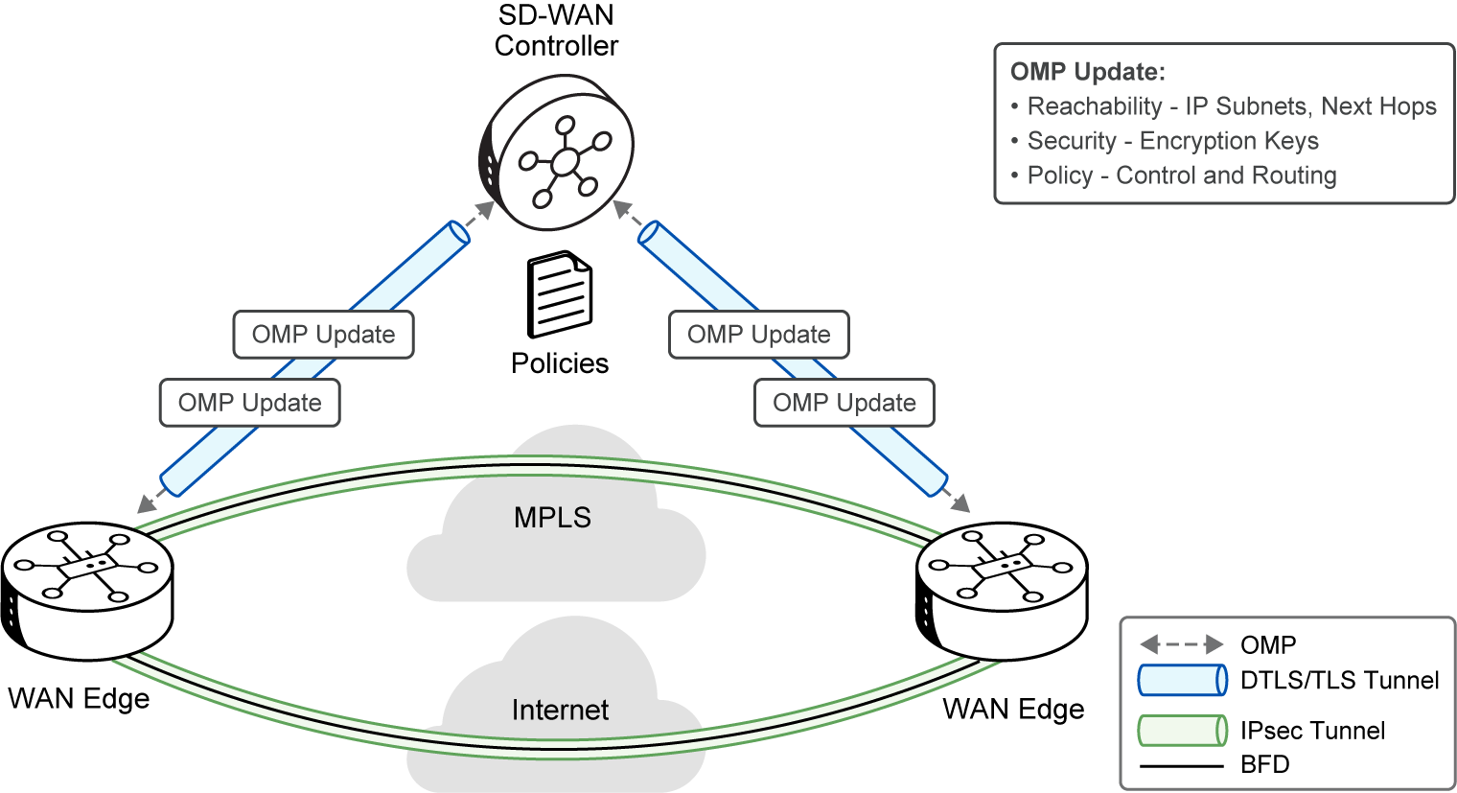
Real-World Scenario: Your network currently uses complex BGP configurations at every branch to manage route distribution. This makes changes slow and error-prone. You need a routing solution that can adapt dynamically to network conditions and policy changes from a single point.
Why it matters: Centralized intelligent routing reduces human error and operational complexity. It allows your network to adapt quickly to changing business needs, ensuring optimal performance and reliability for your critical applications.
Engineer Insight: OMP's centralized intelligence is a game-changer for large-scale WANs. It allows you to think about routing from a policy perspective rather than a hop-by-hop configuration. When designing, remember that the SD-WAN Controller is the source of truth for overlay routing, simplifying route distribution and policy application.
Key Benefits of OMP's Centralized Intelligence
OMP’s centralized intelligence streamlines network operations by optimizing routing, enhancing adaptability, and simplifying management across your SD-WAN environment.
Scaling
Eliminates Scaling Issues:
Explanation: This centralization removes the scaling issues associated with full-mesh routing adjacencies in the transport side of the network. It simplifies large-scale deployments for your organization.
Analogy: Imagine a central air traffic controller managing all flights, rather than each pilot needing to coordinate directly with every other pilot. This makes managing thousands of flights much simpler and more scalable.
Control Plane
Control Plane Only:
Explanation: The Controllers are involved only in control plane communication, not data traffic. This ensures efficient management of provisioning, maintenance, and security for the entire overlay network.
Analogy: The air traffic controller tells planes where to go, but doesn't actually fly the planes themselves.
Adaptation
Dynamic Adaptation:
Explanation: This principle enables the network to dynamically adapt to changing conditions and policy requirements. It ensures optimal traffic flow.
Analogy: The air traffic controller can reroute planes in real-time if a storm appears or a runway becomes unavailable.
Management
Simplified Network Management:
Explanation: Centralized intelligence streamlines the management of provisioning, maintenance, and security across the entire overlay network.
Analogy: Instead of configuring each individual traffic light, you manage the entire city's traffic flow from a central command center.
1. Question: What is the primary benefit of Intelligent Routing powered by OMP in Cisco Catalyst SD-WAN?
A. It eliminates the need for any routing protocols in the network.
B. It centralizes routing intelligence, simplifying management and scaling.
C. It directly forwards data traffic between WAN Edge devices.
D. It only supports static routes for network prefixes.
Network Segmentation (via VPNs)
Cisco Catalyst SD-WAN inherently builds a secure virtual IP fabric. This fabric supports robust Layer 3 segmentation using Virtual Private Networks (VPNs). This principle lets network administrators create multiple isolated segments. It does this without complex signaling protocols, much like Virtual Routing and Forwarding (VRF) instances. Each VPN is isolated from one another. It maintains its own forwarding table. This ensures traffic from different customers or business organizations within your enterprise remains separate and secure. This granular segmentation is crucial for security compliance and efficient traffic management in complex enterprise environments.
By default, the Cisco Catalyst SD-WAN solution includes two main VPNs:
VPN 0
VPN 0 (Transport VPN):
Explanation: This VPN contains the interfaces that connect to the WAN transports (for example, MPLS, Internet). This clearly separates the overlay's control/data plane from the underlying transport network.
Analogy: Think of this as the "service road" or "delivery entrance" to your building. It's how essential supplies (control traffic) get in and out, but it's separate from the main public entrances.
VPN 512
VPN 512 (Management VPN):
Explanation: This VPN carries out-of-band management traffic to and from your Cisco Catalyst SD-WAN devices. It further enhances security by isolating management plane traffic from user data.
Analogy: This is like a dedicated "IT access tunnel" to your building's infrastructure. Only IT personnel use it for maintenance, completely separate from all other traffic.
The following figure illustrates how Cisco Catalyst SD-WAN uses VPNs to provide secure network segmentation.
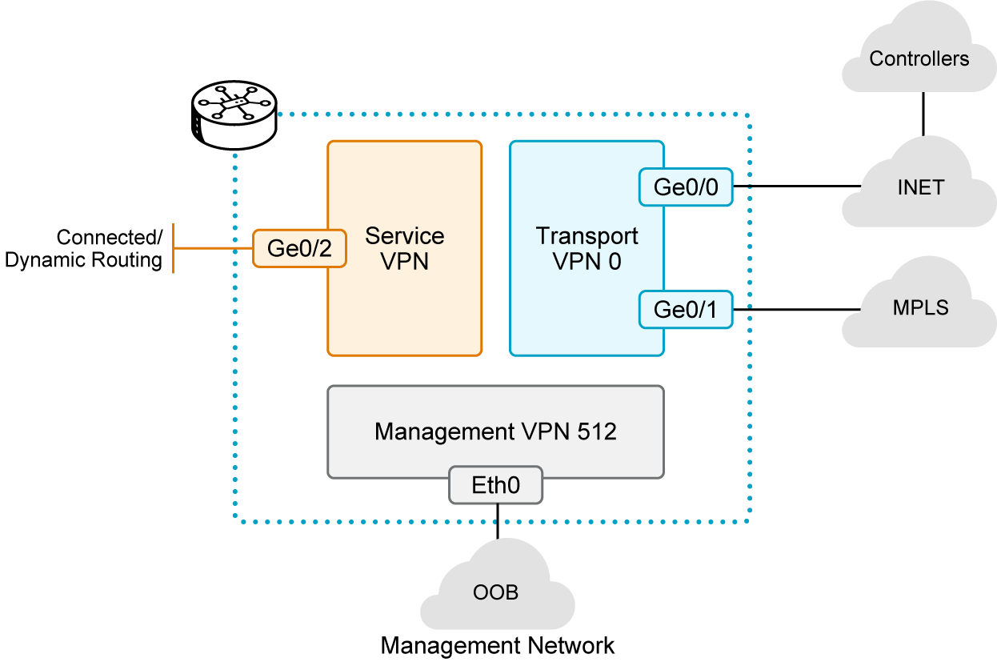
Real-World Scenario: Your company needs to keep employee, guest, and IoT device traffic completely separate for security and compliance reasons. This is true even when they share the same physical network infrastructure at a branch office. Implementing this with traditional VLANs and ACLs across many devices is becoming unmanageable.
Why it Matters: Network segmentation is vital for security, compliance, and multi-tenancy. It allows your company to logically isolate different types of traffic, reducing the attack surface and simplifying policy application.
Engineer Insight: Network segmentation via VPNs is a powerful tool for security and multi-tenancy. It allows you to logically isolate traffic flows, simplifying policy application and reducing the attack surface. When designing, plan your VPNs carefully to align with your business's security zones and traffic separation requirements.
2. Which of the following is a default VPN in Cisco Catalyst SD-WAN used for isolating management traffic?
A. VPN 0
B. VPN 1
C. VPN 512
D. VPN 100
 | Key Takeaway: Your Company's Intelligent Network Control  Cisco Catalyst SD-WAN's intelligent control and architectural design are built on core foundational principles.  By understanding these foundational elements, you can:  - Centralize Network Intelligence: Leverage OMP for dynamic routing and policy distribution across the WAN.  - Establish Secure Segments Utilize VPNs for granular Layer 3 traffic isolation and enhanced security.  This provides your network with the foundational intelligence and structural integrity needed for dynamic, secure, and scalable operations.

Policy and Security Principles
Building on your understanding of intelligent control and network segmentation, let's now explore how Cisco Catalyst SD-WAN translates business intent into network behavior through centralized policies, ensures optimal application performance, and integrates robust security directly into the fabric. These principles are crucial for delivering a truly agile, secure, and responsive WAN for your organization.
 | This topic continues the exploration of Cisco Catalyst SD-WAN's foundational pillars, focusing on how policy management, application awareness, and integrated security collectively address modern networking challenges and contribute to a more efficient, secure, and user-friendly WAN experience.

The core principles guiding the Cisco Catalyst SD-WAN fabric covered in this topic include:
- Centralized Policy Management
- Application-Aware Routing
- Integrated Security

Centralized Policy Management
One of the most powerful principles of Cisco Catalyst SD-WAN is its Centralized Policy Management. You configure policies on a centralized Controller (SD-WAN Controller). These policies strongly influence how prefixes are advertised among routers. They also dictate how traffic flows and how network services are applied. This removes the need to provision policies on each individual router. It drastically simplifies network configuration and ensures consistency across your entire fabric. This approach transforms network management. It moves from a device-by-device approach to a holistic, policy-driven model.
Benefits of Centralized Management
Access Control | Explanation: Determines which prefixes are allowed to communicate within a VPN. This enforces granular security.  Analogy: A central security guard at the entrance of a building decides who can enter specific floors or rooms.
Traffic Engineering | Explanation: Optimizes user experience by influencing transport link choice. This is based on Service Level Agreements (SLAs) or other attributes (for example, "gold" links for critical applications, "bronze" for less critical). It ensures optimal path selection.  Analogy: A central traffic manager directs emergency vehicles onto the fastest, clearest lanes, while less urgent traffic uses other routes.
Business Logic Mapping | Explanation: Allows network administrators to map complex business logic (for example, all finance traffic must go through a specific firewall) from a single, centralized point. This aligns network behavior with business goals.  Analogy: A central planner dictates how different types of traffic (for example, finance, guest) must use specific routes or security checkpoints.
Rapid Response | Explanation: Enables the network to react faster to planned and unexpected situations. This includes rerouting traffic from high-risk countries or during network outages. It enhances network resilience.  Analogy: A central command center can instantly reroute all city traffic if a major road is closed due to an accident.
Service Center | Explanation: Facilitates centralizing services like firewalls, Identity Providers (IdPs), and Intrusion Detection Systems (IDSs). This achieves economies of scale and minimizes touch points for provisioning. It reduces deployment and management overhead.  Analogy: Instead of having a separate security checkpoint at every door, you manage all security operations and services from a central, highly efficient security operations center.

The following figure illustrates how the SD-WAN Controller distributes OMP updates and policies to WAN Edge devices, and how control and data tunnels form across the underlay.

Real-World Scenario: You need to implement a new security policy. This policy dictates that all traffic from your sales department must traverse a specific cloud security service before reaching the internet. With your traditional WAN, this would involve manual configuration changes on dozens of routers.
Why it matters: Centralized policy management dramatically simplifies network operations. It reduces configuration errors, ensures consistent security and performance across your entire WAN, and allows your company to respond rapidly to new business requirements.
Engineer Insight: Centralized policy management is where SD-WAN truly shines in simplifying operations. Instead of configuring each device, you define business intent once, and the system applies it everywhere. This dramatically reduces configuration errors and ensures consistent behavior across your entire WAN. When troubleshooting, always start by verifying the centralized policy, as it's the single source of truth for network behavior.
1. A network administrator wants to apply a new traffic steering rule that affects all branches globally. Which Cisco Catalyst SD-WAN principle best enables this with minimal effort?
A. Zero-Touch Provisioning
B. Network Segmentation
C. Distributed Routing
D. Centralized Policy Management
Application-Aware Routing
Building on the foundation of centralized policy and intelligent routing, Cisco Catalyst SD-WAN includes Application-Aware Routing. This principle ensures that critical applications receive the necessary network resources and optimal paths. This leads to a superior user experience for your employees. The system identifies applications (often using Deep Packet Inspection - DPI). Then, it steers their traffic over the optimal path. This is based on real-time network conditions and predefined Service Level Agreements (SLAs). This ensures a superior user experience for critical applications. This dynamic traffic steering goes beyond traditional routing, which only focuses on network reachability. Instead, it prioritizes actual application performance.
The following figure illustrates how Application-Aware Routing uses real-time path measurements and policy thresholds to choose the best path between sites.
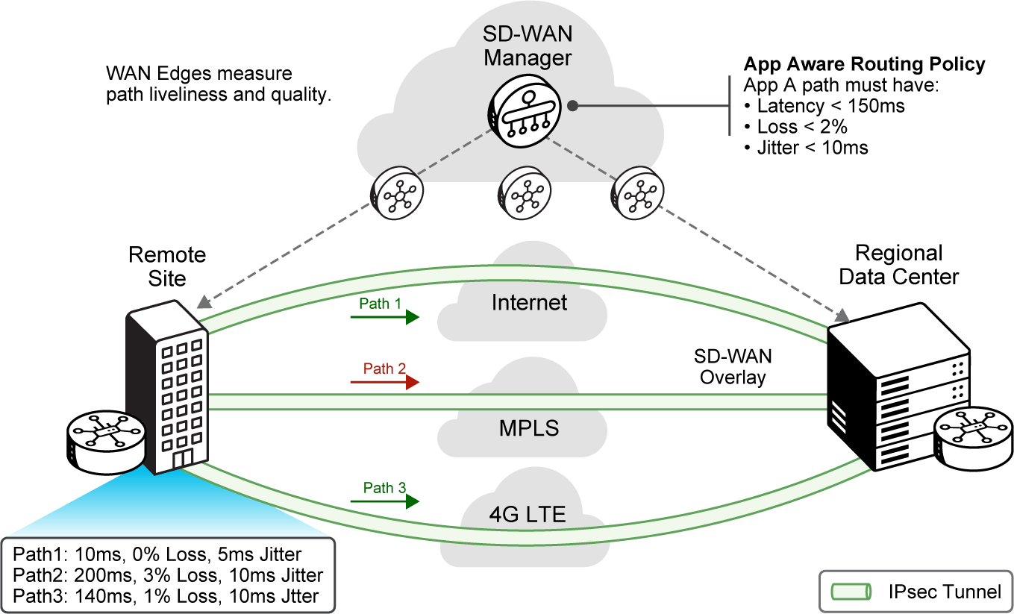
Real-World Scenario: Your security team is struggling to apply consistent security policies across all branch offices due to fragmented deployments and varying capabilities. You need a solution that inherently builds strong, uniform security into the network fabric, from device onboarding to data in transit.
Why it matters: Application-aware routing directly impacts employee productivity and customer satisfaction. By ensuring critical applications always perform optimally, your company can maintain seamless operations and deliver high-quality services.
Engineer Insight: Application-Aware Routing is key to delivering a consistent user experience. It allows you to align network behavior directly with business priorities. Instead of simply routing packets, you're routing applications intelligently. This ensures that your most important business tools always perform optimally, even if network conditions fluctuate.
Tip: Application-aware routing in Cisco Catalyst SD-WAN moves beyond basic packet forwarding. It intelligently understands and prioritizes your business-critical applications, ensuring optimal performance and user experience even across diverse WAN links.

2. How does Cisco Catalyst SD-WAN improve application performance compared to traditional WANs?
A. By eliminating the need for any network policies.
B. By backhauling all application traffic to a central data center.
C. By deploying Application-Aware Routing (AAR) to intelligently route traffic based on application needs.
D. By relying solely on manual configuration for application prioritization.
Integrated Security
Security is not an afterthought. It is an integral principle woven into the very fabric of Cisco Catalyst SD-WAN. The solution builds a robust security architecture. This is crucial for hybrid networks. It provides a strong policy framework across your data centers, branches, campuses, and colocation facilities. This ensures your network is not prone to attacks from the transport side. It also guarantees that all data and control plane communications are protected by design. This design-centric approach to security uses these key aspects:
Benefits of Integrated Security
Zero-Trust Foundation | Explanation: All devices participating in the network are authenticated and continuously verified. This ensures only trusted entities can access and operate within the fabric. This "never trust, always verify" approach minimizes the attack surface.  Analogy: Every person entering a secure facility must show ID and pass through a checkpoint, even if they've been there before.
Secure Tunnels | Explanation: Secure Tunnels establish encrypted and authenticated virtual private connections between SD-WAN devices over any transport network. These connections encapsulate all data traffic, ensuring its confidentiality, integrity, and authenticity by forming a private, protected pathway across public or private infrastructure.  Analogy: Your sensitive data travels in armored, encrypted vehicles between secure locations.
Control Plane Protection | Explanation: The control plane is secured using DTLS/TLS. This protects against unauthorized access and Distributed Denial of Service (DDoS) attacks. It ensures the integrity of the network's intelligence.  Analogy: The command center for your secure transport system has its own highly fortified communication channels, separate from the data being transported.
Centralized Security Services: | Explanation: Policies can centralize services like firewalls, Identity Providers (IdPs), and Intrusion Detection Systems (IDSs). This achieves economies of scale and minimizes touch points for provisioning. It reduces deployment and management overhead.  Analogy: Instead of having a separate security checkpoint at every door, you manage all security operations and services from a central, highly efficient security operations center.

The following figure illustrates how Cisco Catalyst SD-WAN secures both the control plane and data plane using DTLS/TLS and IPsec.
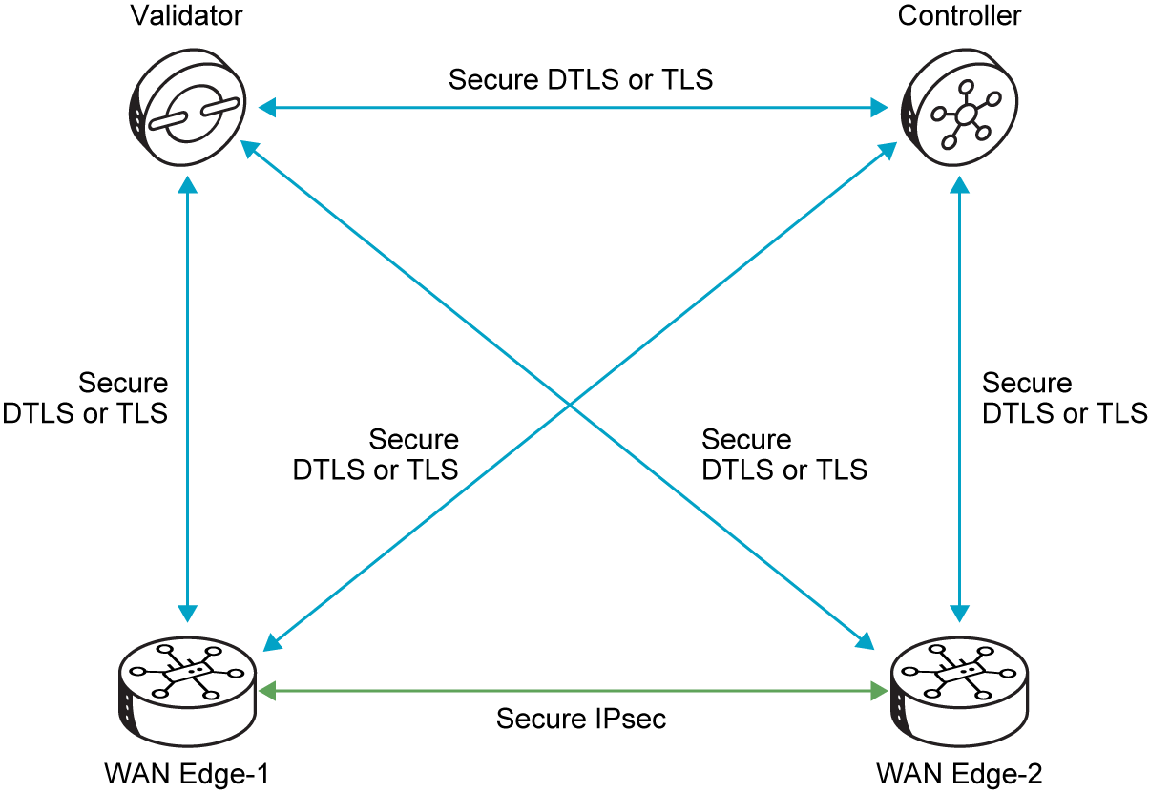
Real-World Scenario: Your company's compliance officer requires proof that all data transmitted across the WAN, including over public internet links, is encrypted and that only authenticated devices can join the network. Implementing this manually across hundreds of sites with diverse security appliances is proving complex and error-prone.
Why it Matters: Integrated security is paramount for protecting your company's assets and maintaining trust. It simplifies compliance, reduces the risk of breaches, and provides a unified defense against sophisticated cyber threats.
Engineer Insight: Integrated security means that security is 'baked in" not "bolted on." This architectural approach ensures that every device and every data flow is protected from the moment it joins the fabric. As an engineer, focus on designing security policies that align with your organization's risk profile, knowing that the underlying Cisco Catalyst SD-WAN fabric provides a strong, consistent defense.
3. Which core principle ensures that all devices joining the Cisco Catalyst SD-WAN fabric are authenticated and continuously verified for legitimacy?
A. Simplified Management
B. Application-Aware Routing
C. Integrated Security
D. Intelligent Routing
 | Think Like an Engineer: Policy-Driven WAN Transformation  Your CEO asks you to maximize the impact of your SD-WAN deployment with limited resources. Which two policy-driven Cisco Catalyst SD-WAN capabilities (Centralized Policy Management, Application-Aware Routing, Integrated Security) would you prioritize first, and why?  - Consider which choices will most effectively improve business agility, application performance, and security in a cloud-first, distributed enterprise.

 | Key Takeaway: Your Company's Policy-Driven Security  Cisco Catalyst SD-WAN transforms network management through its policy enforcement and integrated security capabilities.  By leveraging these principles, you can:  - Enforce Business Intent: Apply centralized policies for consistent networkwide behavior and rapid response to changing needs.  - Optimize Application Performance: Leverage application-aware routing to ensure that critical applications always use the best path.  - Build a Resilient Fabric: Establish a secure and adaptable network architecture that meets modern demands for performance, control, and security.  This enables your network to intelligently enforce business intent, deliver superior application experiences, and maintain a robust, adaptable security posture across your distributed environment.

Agile Operations and Review
Having explored Cisco Catalyst SD-WAN's architectural, intelligent control, and policy & security principles, we will now turn our attention to the operational pillars that drive efficiency and agility. These principles are vital for rapid deployment, streamlined management, and ensuring your network can quickly adapt to evolving business demands.
 | This topic focuses on the core principles that enable rapid deployment and simplified day-to-day management, culminating in a comprehensive review of all foundational Cisco Catalyst SD-WAN concepts.

The core principles guiding the Cisco Catalyst SD-WAN fabric covered in this topic include:
- Zero-Touch Provisioning (ZTP)
- Simplified Management

Zero-Touch Provisioning (ZTP)
Zero-Touch Provisioning (ZTP) is a cornerstone of Cisco Catalyst SD-WAN's operational simplicity and scalability. This principle automates the onboarding and fabric registration of WAN Edge devices. It significantly reduces manual configuration effort. It also accelerates deployment timelines for your company. When a new WAN Edge device is powered on, it automatically contacts the SD-WAN Validator. It authenticates itself. It registers with the SD-WAN Manager. Finally, it securely joins the fabric. This process transforms what could be weeks of manual setup into hours for large-scale rollouts. It allows devices to be deployed in remote locations without requiring on-site technical personnel for initial setup.
The following figure illustrates the Zero-Touch Provisioning (ZTP) workflow using Cisco plug-and-play (PnP) to onboard a new SD-WAN device automatically.
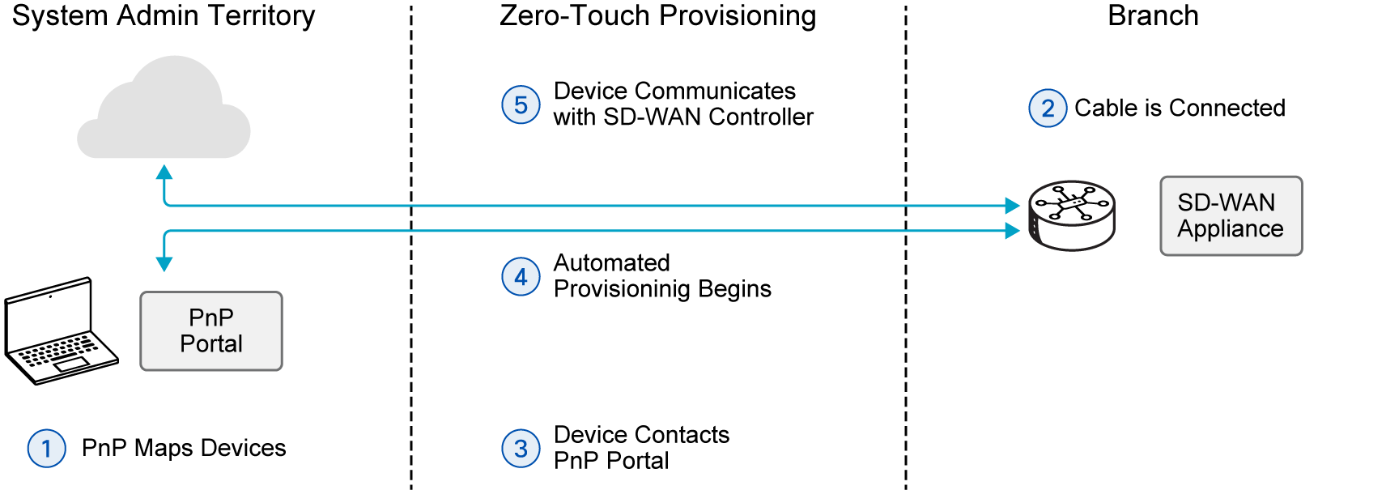
Real-World Scenario: Your company is experiencing explosive growth and plans to open 50 new branch offices across the country next quarter.simultaneously. Manually configuring each WAN edge router on-site would take weeks and require significant travel for your engineering team. As the Senior Network Architect, you need a solution to rapidly deploy these new sites with minimal human intervention.
Why it matters: ZTP dramatically accelerates network expansion. It reduces deployment costs and frees up your valuable engineering resources. This allows your company to quickly capitalize on new business opportunities.
Engineer Insight: ZTP is invaluable for scaling your WAN efficiently. It allows you to deploy devices without requiring highly skilled personnel on-site for initial setup. This dramatically accelerates branch rollouts. This frees up your engineering team to focus on strategic design and optimization rather than repetitive configuration tasks.
Tip: Zero-Touch Provisioning isn't just a convenience; it's a strategic advantage. It enables rapid, hands-free deployment of new sites, allowing your business to expand quickly without needing skilled IT staff on-site for initial setup.

1. What is the primary operational benefit of Zero-Touch Provisioning (ZTP) in Cisco Catalyst SD-WAN deployments?
A. It automates device onboarding and configuration, minimizing manual intervention.
B. It centralizes policy enforcement across the entire fabric.
C. It ensures end-to-end encryption for all data traffic.
D. It provides real-time monitoring of application performance.
Simplified Management
The principle of Simplified Management is embodied by the SD-WAN Manager. It provides an intuitive GUI (GUI) for all Day 0, Day 1, and Day 2 operations. This centralized platform for network management streamlines monitoring, configuration, and maintenance of all devices and links in your overlay network. This unified approach drastically reduces operational overhead and the potential for human error. It makes complex network operations more manageable and efficient for your team.
This unified approach, embodied by the SD-WAN Manager, translates into several key benefits for your team, including:
Provision
Efficient Provisioning:
Explanation: GUI-based templates and workflows ease service provisioning. This allows administrators to push configurations to multiple devices simultaneously and consistently.
Analogy: Instead of manually setting up each new computer, you can deploy a standardized software image to hundreds of machines with a few clicks.
Visibility
Improved Network Visibility:
Explanation: Provides networkwide insights, such as VPN statistics, device health, and application performance, from a single point. This offers a holistic view of the fabric's health and performance.
Analogy: A single dashboard shows the real-time status of all your company's delivery trucks, rather than checking each one individually.
Troubleshoot
Streamlined Troubleshooting:
Explanation: Troubleshooting tasks are simplified and presented visually through dashboards and integrated tools. This reduces the need for network administrators to parse lengthy configurations or CLI outputs from individual devices. It accelerates problem resolution.
Analogy: Instead of sifting through pages of diagnostic codes, a visual map highlights the exact section of a complex machine that is malfunctioning.
The following figure shows how Cisco Catalyst SD-WAN centralizes management and control across all WAN transports and sites.
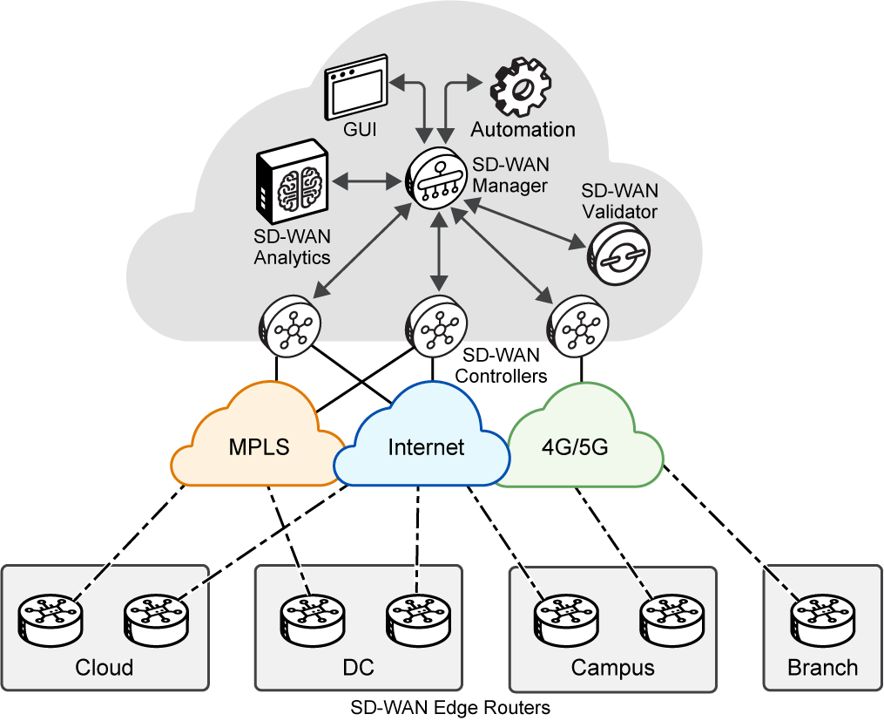
Real-World Scenario: Your team spends hours each week logging into individual routers to check status, apply configuration changes, and troubleshoot issues. You need a way to manage and monitor your entire WAN from one central location, reducing operational burden and potential for errors.
Why it matters: Simplified management reduces operational costs and minimizes human error. It allows your IT staff to be more productive and focus on strategic initiatives, directly contributing to your company's efficiency.
Engineer Insight: A unified management platform radically changes your day-to-day. It moves you from reactive, device-level firefighting to proactive, networkwide strategic management. Embrace the GUI for most tasks, but understand the underlying principles so you can effectively troubleshoot when needed.
Tip: Agile operations in Cisco Catalyst SD-WAN mean less time on manual tasks and more time on strategic initiatives. Features like Zero-Touch Provisioning and centralized management directly translate to faster deployments and reduced operational overhead for your team.

2. Which component provides a consolidated view for centralized management, monitoring, and troubleshooting of the entire Cisco Catalyst SD-WAN fabric?
A. WAN edge router
B. SD-WAN Controller
C. SD-WAN Validator
D. SD-WAN Manager
Core Principles: Recap of Each Pillar
Let's recap the foundational principles that collectively enable Cisco Catalyst SD-WAN's agility, security, and efficiency:
Intelligent Routing (OMP) | Centralizes routing intelligence, simplifies management, and enables dynamic path selection.  (OMP stands for Overlay Management Protocol.)
Network Segmentation (VPNs) | Creates isolated network segments for different traffic types, enhancing security and compliance.
Centralized Policy | Networkwide rules configured from a single point (SD-WAN Manager/SD-WAN Controller) for consistent application.
Application-Aware Routing | Identifies and prioritizes critical applications, steering them over optimal paths based on Service Level Agreements (SLAs).
Zero-Touch Provisioning (ZTP) | Automates device onboarding and fabric registration, accelerating deployments and reducing manual effort.
Simplified Management | Provides a single pane of glass for all operations, streamlining monitoring, configuration, and troubleshooting.
Integrated Security | Builds security into the fabric, with zero-trust authentication, encrypted tunnels, and centralized services.
Deep Packet Inspection (DPI) | Used for application identification, enabling Application-Aware Routing based on performance needs.
SD-WAN Manager | The unified management console providing a single pane of glass for all operations.
IPsec/DTLS/TLS | Key technologies for Integrated Security, providing encrypted tunnels and secure control plane communication.  (IPsec stands for Internet Protocol Security, DTLS for Datagram Transport Layer Security, and TLS for Transport Layer Security.)

3. Which of the following is a direct benefit of the "Simplified Management" principle in Cisco Catalyst SD-WAN?
A. Reduced reliance on expensive MPLS circuits.
B. Automated device onboarding without manual intervention.
C. Decreased operational overhead and potential for human error.
D. Dynamic steering of application traffic based on real-time conditions.
 | Think Like an Engineer: Accelerating WAN Edge Deployment  A network administrator needs to rapidly deploy new WAN Edge devices in remote offices. Which core principle of Cisco Catalyst SD-WAN would be most beneficial for this task?  - Consider how automation, reduced manual effort, and standardized onboarding contribute to accelerating deployments and minimizing on-site technical requirements.

 | Key Takeaway: The Pillars of Your Modern WAN  The core principles of Cisco Catalyst SD-WAN collectively enable a highly agile, secure, and efficient network for your company.  By understanding these foundational elements, you can:  - Drive Business Agility: Leverage automation and centralized control for rapid deployment and adaptation to changing demands.  - Ensure Robust Security: Build security into the network's foundation, protecting your assets and ensuring compliance.  - Optimize Performance: Prioritize critical applications and deliver a superior user experience across your distributed environment.  - Simplify Operations: Reduce complexity and human error through unified management and automated provisioning.  These principles empower your organization to transform its network into a strategic asset, ready for the demands of the digital age.

Cisco Catalyst SD-WAN: Unlocking Modern WAN Agility – A Strategic Imperative

Summary
Congratulations! You completed the Cisco Catalyst SD-WAN: Evolution and Core Concepts course—a key milestone in building your confidence and capability in modern WAN networking.
Throughout this course, you explored the fundamental shift from traditional WAN architectures to the agile, secure, and intelligent world of Cisco Catalyst SD-WAN. From understanding the critical limitations of legacy networks to grasping the visionary underlay/overlay architecture and its core principles, you’ve now seen what it takes to design a network that is both responsive and resilient.
Using a real-world case study, you followed the journey of modernizing an enterprise WAN, from identifying pain points like slow cloud applications and rigid deployments to advocating for a transformative solution. Along the way, you made key decisions that mirrored those of real network engineers—choices about leveraging diverse transport options, centralizing management, and building security into the fabric. This practical context helped you understand how each concept fits into the bigger picture, working together to build a secure, scalable, and efficient WAN.
What You Learned
You are now proficient in the following essential building blocks:
- Identify the key limitations of traditional WANs, such as high costs, complexity, rigidity, inefficient backhauling, limited application awareness, and security gaps, in the face of modern cloud and remote work trends.
- Explain the business drivers and technical advantages of Cisco Catalyst SD-WAN, including enhanced business agility, simplified management, robust security, intelligent application awareness, and improved cost-efficiency.
- Differentiate between the underlay and overlay architectures, understanding their distinct roles and interdependencies in forming the SD-WAN fabric.
- Describe the core principles of the Cisco Catalyst SD-WAN fabric, such as Intelligent Routing (OMP), Layer 3 Segmentation (VPNs), Centralized Policy Management, Application-Aware Routing, Zero-Touch Provisioning (ZTP), Simplified Management, and Integrated Security.

What Does This Mean for Your Day-to-Day Work?
Now that you understand the foundational concepts, you can apply this knowledge in practical ways—whether you're identifying shortcomings in legacy WANs, advocating for modernization initiatives, or preparing to design and deploy Cisco Catalyst SD-WAN solutions. Every principle you've learned—from intelligent routing to zero-touch provisioning—can directly improve the performance, security, and manageability of the networks you support.
You can apply this knowledge in the following ways:
- Diagnose traditional WAN inefficiencies and articulate their impact on business operations and user experience.
- Justify the adoption of Cisco Catalyst SD-WAN by clearly linking its features to tangible business value and strategic goals.
- Communicate the fundamental architecture of SD-WAN, distinguishing between the physical underlay and the intelligent overlay.
- Leverage core SD-WAN principles to design more agile, secure, and cost-effective network solutions.

What's Next?
SD-WAN technologies continue to evolve—with advancements in policy automation, cloud integration, and advanced security features shaping the future. Continue exploring topics like SD-WAN deployment, advanced policy configuration, and troubleshooting to stay ahead of the curve.
Your journey does not stop here. Keep learning. Keep growing.

Summary Challenge
1. Which of the following is NOT a common limitation of traditional WAN architectures in modern enterprises?
A. Rapid deployment times for new branch offices and services.
B. Inherent complexity from distributed control planes requiring per-device configuration.
C. High operational costs due to reliance on expensive dedicated circuits.
D. Inefficient backhauling of cloud-bound traffic, causing latency..
2. In Cisco Catalyst SD-WAN, which component serves as the centralized platform for comprehensive network operations, streamlining configuration, monitoring, and troubleshooting?
A. Cisco Catalyst SD-WAN Validator
B. Cisco Catalyst SD-WAN Controller
C. WAN edge router
D. Cisco Catalyst SD-WAN Manager
3. The primary role of the underlay network in a Cisco Catalyst SD-WAN deployment is to:
A. Enforce intelligent policy and application-aware routing.
B. Provide basic IP connectivity and reachability between physical network devices.
C. Establish secure, encrypted tunnels for application traffic.
D. Orchestrate the centralized control plane of the SD-WAN fabric
4. Which of the following best describes the overlay network in Cisco Catalyst SD-WAN?
A. It is composed solely of physical routers and direct cable connections.
B. Its primary function is to provide basic IP reachability between network components.
C. It is a logical network of secure, encrypted tunnels built on top of the underlay.
D. It operates completely independently, without any reliance on the underlay network.
5. Which Cisco Catalyst SD-WAN core principle automates the onboarding and fabric registration of WAN Edge devices, significantly reducing manual configuration effort?
A. Intelligent Routing (OMP)
B. Network Segmentation (VPNs)
C. Centralized Policy Management
D. Zero-Touch Provisioning (ZTP)
6. Cisco Catalyst SD-WAN leverages Virtual Private Networks (VPNs) primarily to achieve:
A. Robust network segmentation and isolation of network traffic.
B. Automated software updates for all WAN Edge devices.
C. Dynamic load balancing across multiple transport links.
D. Enhanced network visibility through real-time traffic analysis.
7. Which of the following is a key aspect of Integrated Security in Cisco Catalyst SD-WAN?
A. Relying solely on perimeter firewalls for all network protection.
B. Authenticating and continuously verifying all devices participating in the network.
C. Eliminating the need for any encryption for internal network traffic.
D. Distributing security policies to individual devices for independent, localized enforcement.

Answer Key
Traditional WAN Limitations and Modern Demands
- C
- D

Business Drivers and SD-WAN Value
- B

- A

Underlay vs. Overlay Architecture
- B

- D

- A

Intelligent Control Principles
- B

- C

Policy and Security Principles
- D

- C

- C

Agile Operations and Review
- A

- D

- C

Summary Challenge
- A
- D
- B
- C
- D
- A
- B

